PROJECT REPORT

Intelligent Customer Help Desk with Smart

Document Understanding

Category: Artificial Intelligence Developer

Application ID:SPS_APL_20200000588

Project ID: PS_PRO_99

Internship at SmartInternz

Moksha Shah

moksha1208[@gmail.com](mailto:hashimirfan99@gmail.com)

|  |  |  |
| --- | --- | --- |
| **1** | **INTRODUCTION** |  |
|  | 1.1 Overview |  |
|  | 1.2 Purpose |  |
| **2** | **LITERATURE SURVEY** |  |
|  | 2.1 Existing problem |  |
|  | 2.2 Proposed solution |  |
| **3** | **THEORETICAL ANALYSIS** | |
|  | 3.1 Block diagram |  |
| 3.2 Hardware / Software designing | | |
| **4** | **EXPERIMENTAL INVESTIGATIONS** | |
| **5** | **FLOWCHART** |  |
| **6** | **RESULT** |  |
| **7** | **ADVANTAGES & DISADVANTAGES** | |
| **8** | **APPLICATIONS** |  |
| **9** | **CONCLUSION** |  |
| **10** | **FUTURE SCOPE** | **`** |
| **11** | **BIBLIOGRAPHY** |  |
|  | **APPENDIX** |  |
|  | 1. Source code 2. Reference |  |

# INTRODUCTION

## Overview

We use the typical customer care chatbot experience but instead of relying on predefined responses, our dialog will provide a hook that can call out to other IBM Watson services for additional sources of information. In our case, it will be an owner’s manual that has been uploaded into Watson Discovery.

* 1. Purpose

The purpose is to Enhance the customer help desks with Smart Document Understanding using webhooks in Watson Assistant.

1. **LITERATURE SURVEY**
   1. Existing Problem

The typical customer care chatbot can answer simple questions, such as store locations and hours, directions, and maybe even making appointments. When a question falls outside of the scope of the predetermined question set, the option is typically to tell the customer the question isn’t valid or offer to speak to a real person.

* 1. Proposed solution

In this project, If the customer question is about the operation of a device, the application shall pass the question onto Watson Discovery Service, which has been pre-loaded with the device’s owner’s manual. So now, instead of “Would you like to speak to a customer representative?” We can return relevant sections of the owner’s manual to help solve our customers’ problems.

To take it a step further, the project shall use the Smart Document Understanding feature of Watson Discovery to train it on what text in the owner’s manual is important and what is not. This will improve the answers returned from the queries.

1. **THEORETICAL ANALYSIS**
   1. Block Diagram

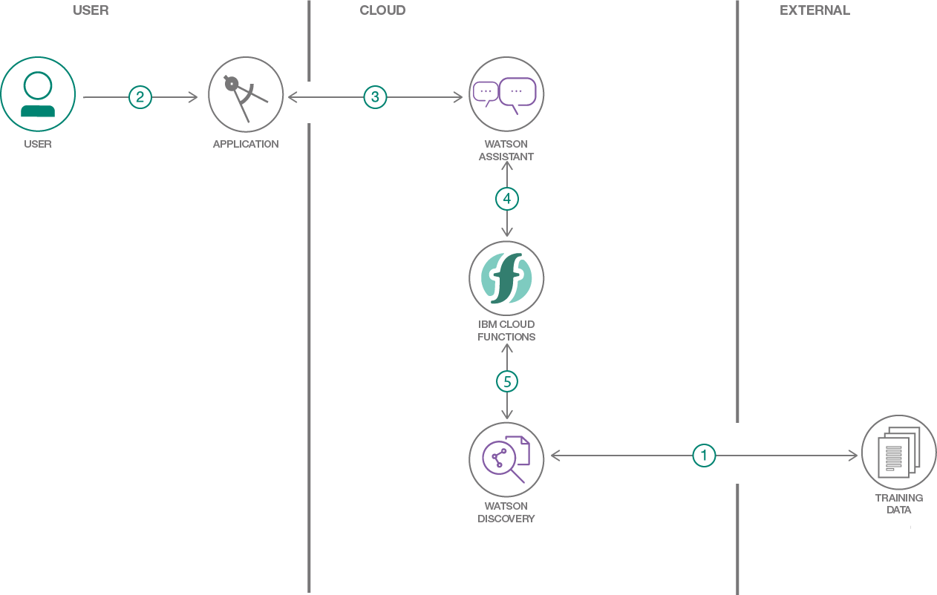

* 1. Hardware / Software designing
     1. Create IBM Cloud Services
     2. Configure Watson Discovery
     3. Create IBM Cloud Functions action
     4. Configure Watson Assistant
     5. Build Node-RED Flow to Integrate All Services
     6. Configure the nodes and Build A Web Dashboard in Node-RED
     7. Deploy and Run the application

**4. EXPERIMENTAL INVESTIGATIONS**

1. **Create IBM Cloud Services**

To Create IBM Cloud, go to <https://www.ibm.com/cloud>

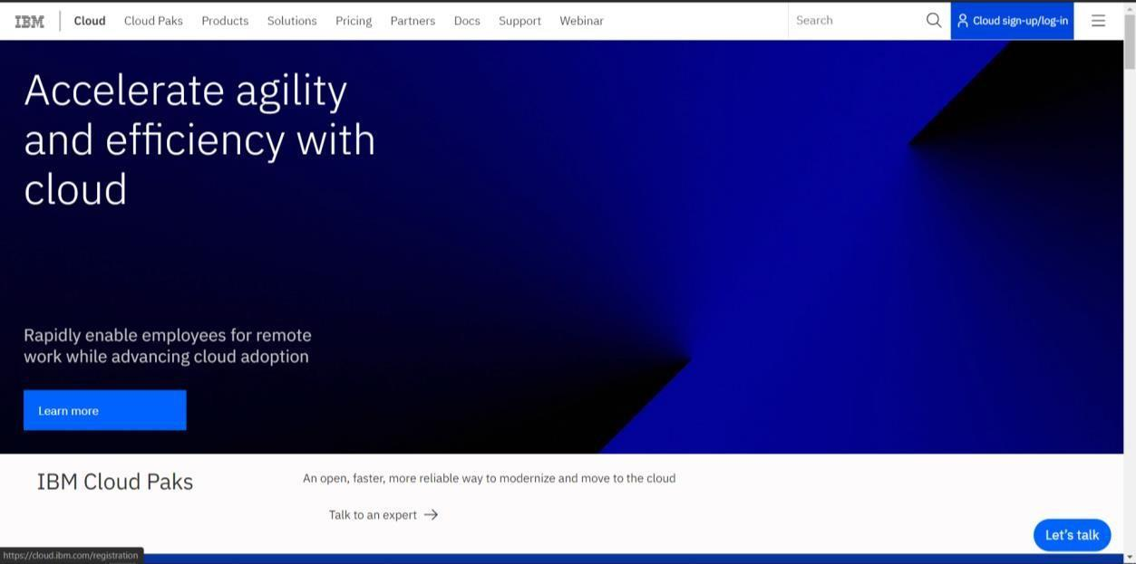

Click on  to sign up or login to IBM Cloud.

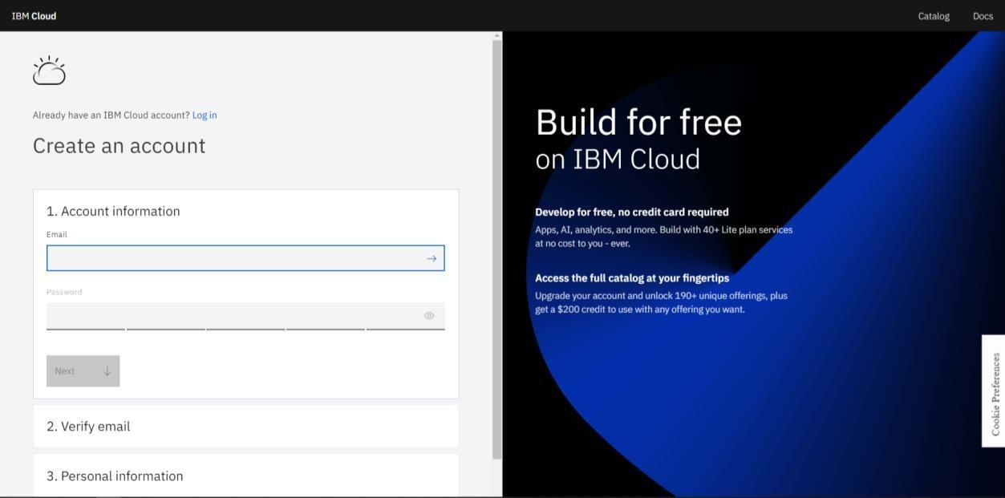

For Cloud Sign-Up: Follow the steps on the screen and fill in all the required details to create a new cloud account

For Cloud Log In, click on  and Log in to your cloud account.

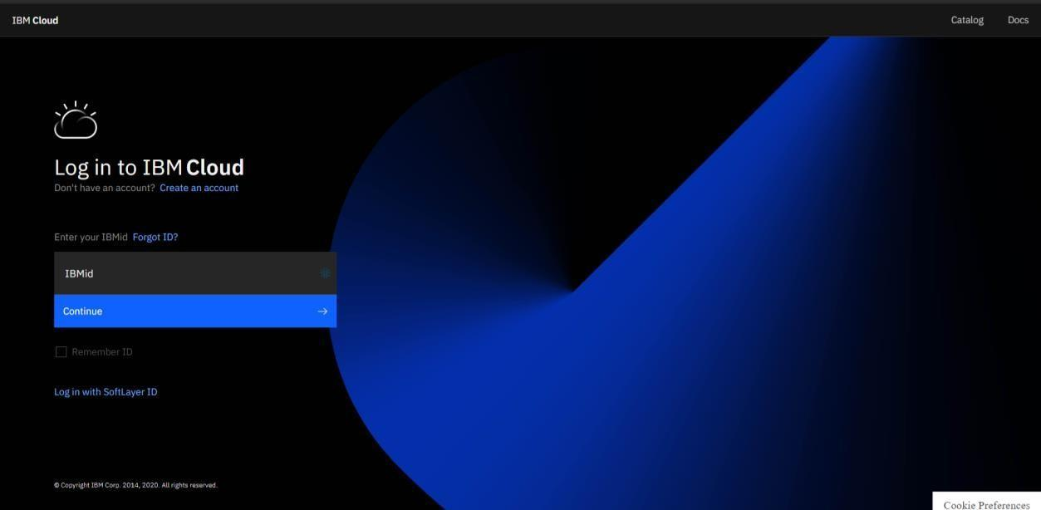

After Logging in, you can see the IBM Cloud Dashboard.

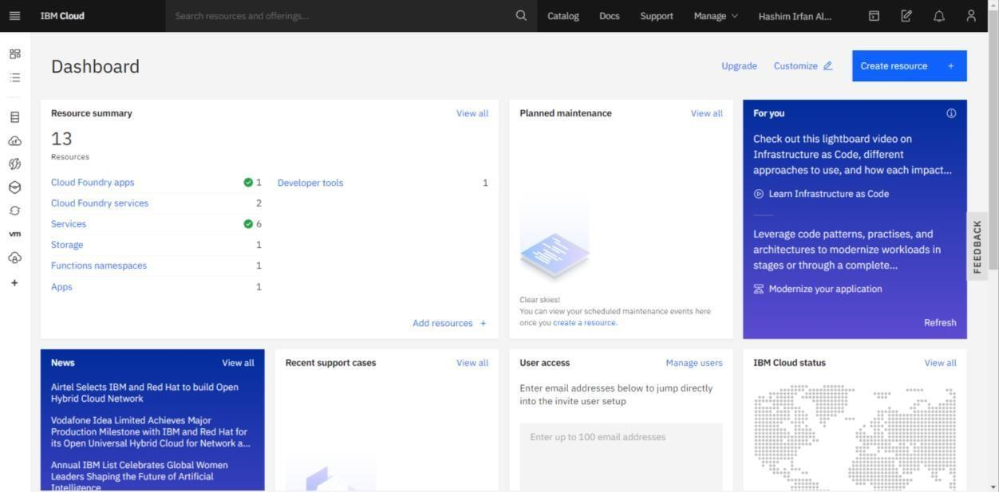

To Create any Resource (Services/Apps/etc), click on 

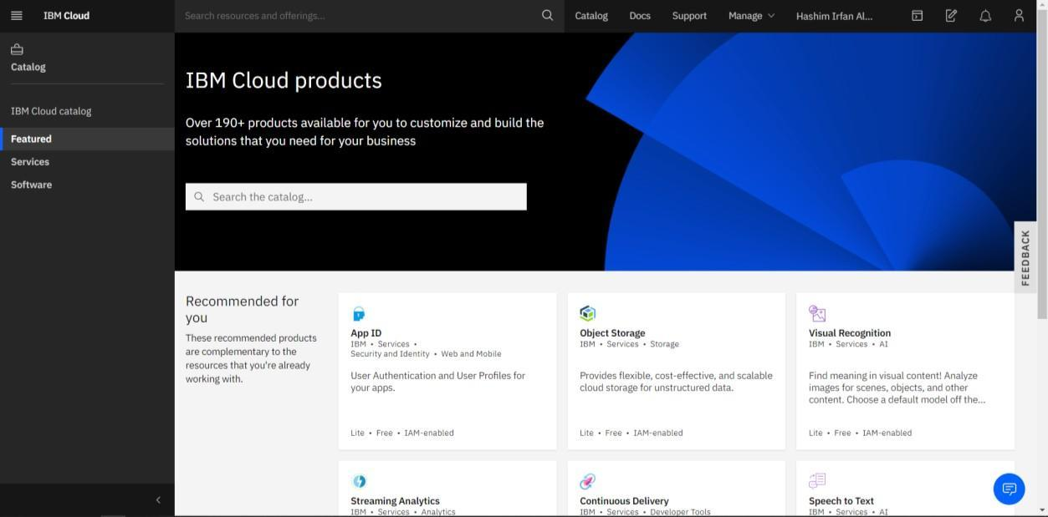

Using the search box, we can find the service we want.

For this project, we need to Create the following services:

* 1. Watson Discovery
  2. Watson Assistant

1. To create a Watson Discovery Service, search for Discovery in the search box

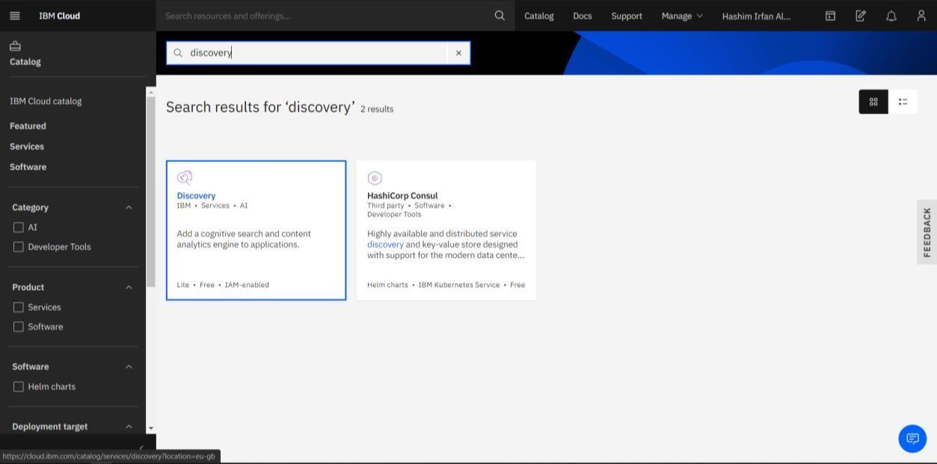

Click on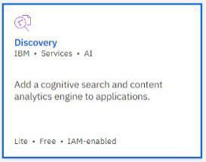

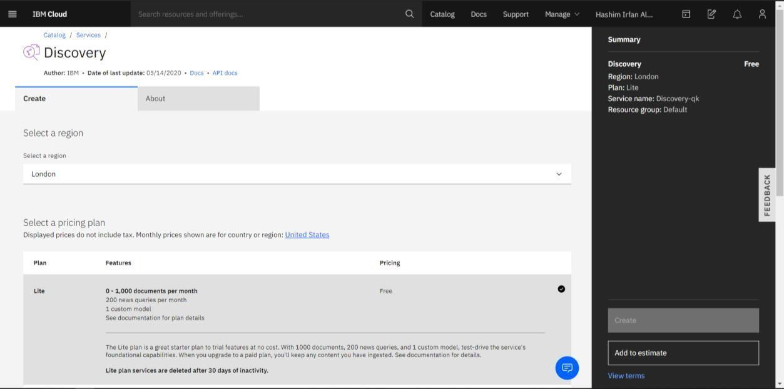

Select a region, select a plan, configure your service (Service name, etc) and click Create.

Your Watson Discovery service is created successfully.

(If you are on Lite Plan, you can have only one instance per service)

1. To create a Watson Assistant Service, search for Assistant in the search box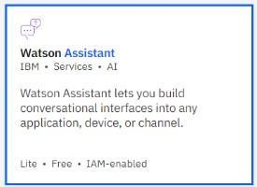

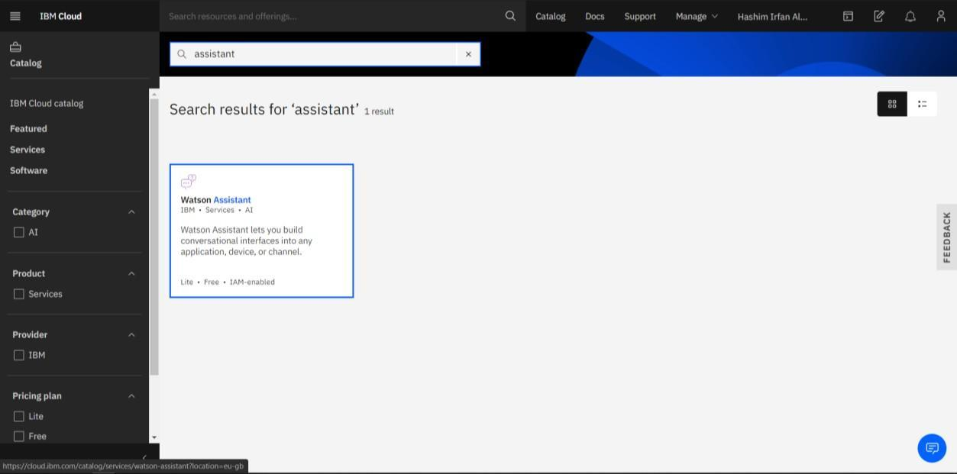

Click on

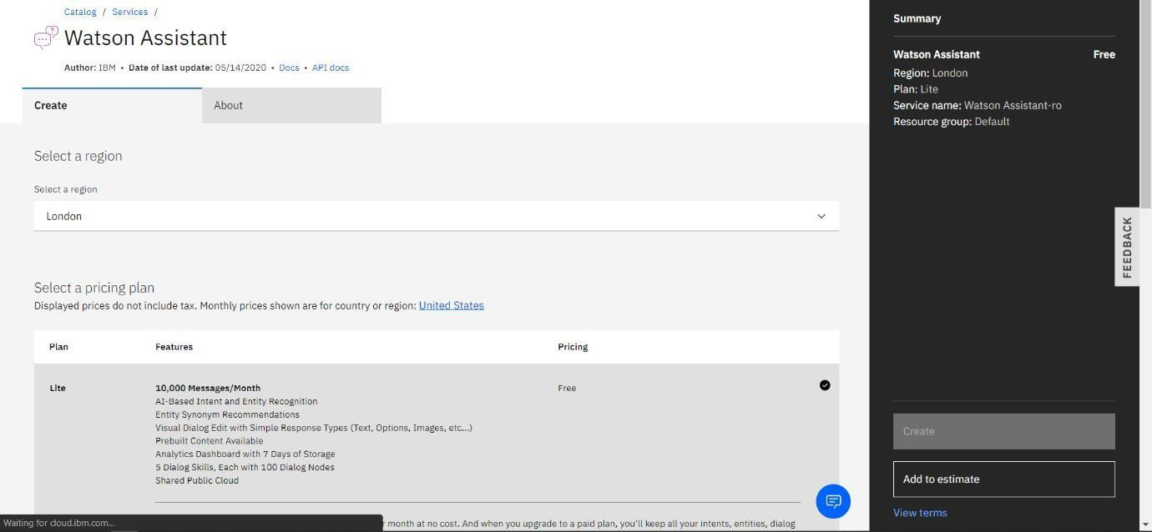

Select a region, select a plan, configure your service (Service name, etc) and click Create.

Your Watson Assistant service is created successfully.

(If you are on Lite Plan, you can have only one instance per service)

To check whether you have correctly configured the services, go back to the IBM Dashboard and click on View All from the Resource Summary Tab.

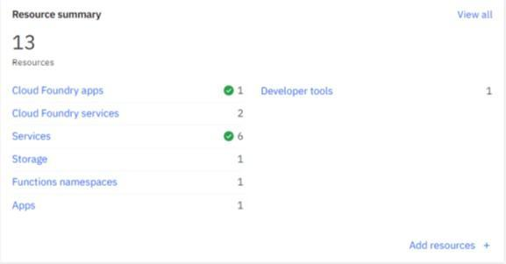

All of your existing Resource list will be shown here, click on Services to unveil the list of services you have.

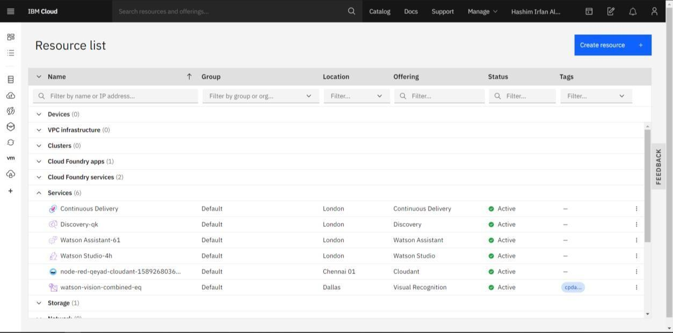

Here we can find that the status of Watson Discovery and Watson Assistant as Active which means we have configured the services correctly.

1. **Configure Watson Discovery**

From the resource list screen, click  to open Watson Discovery service.

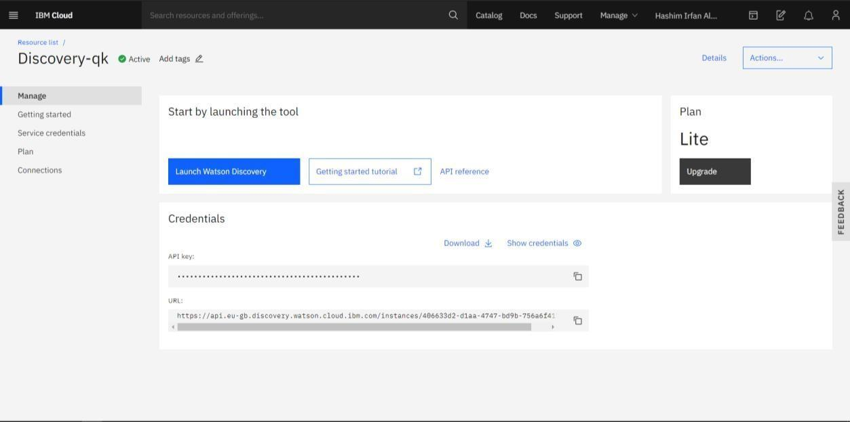

Click on to launch Watson Discovery Service.

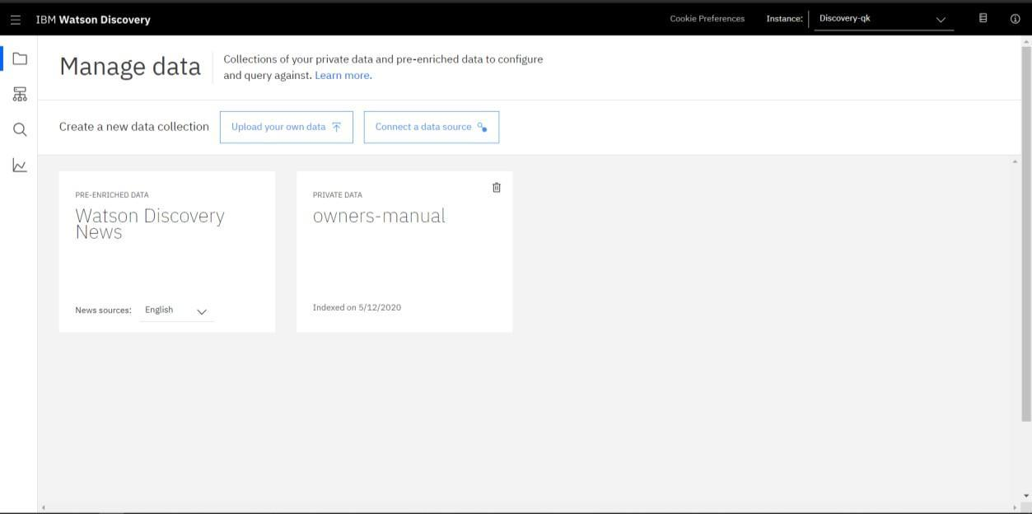

Click on  to create a new data collection.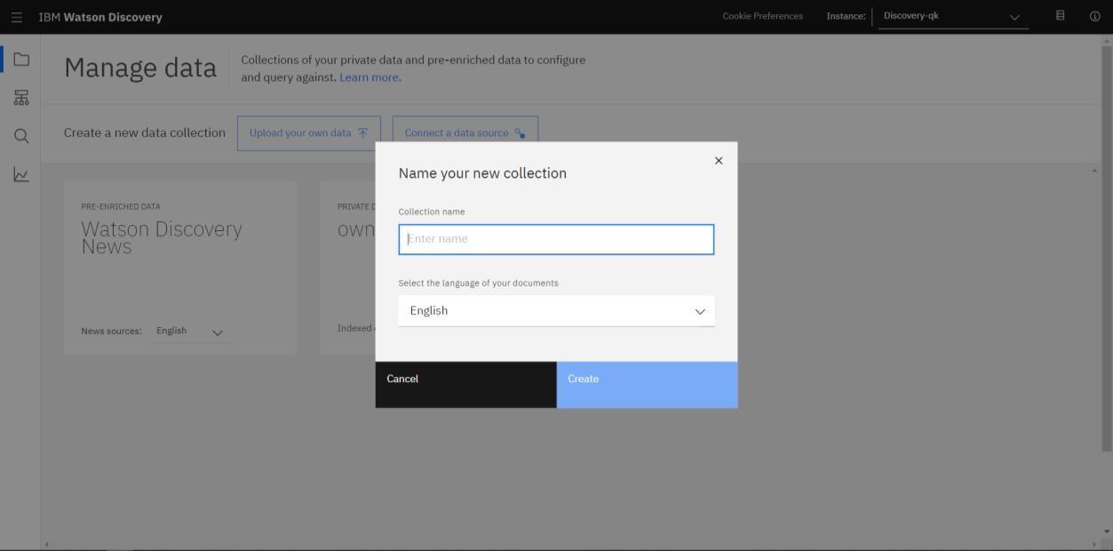

Give the data collection a unique name.

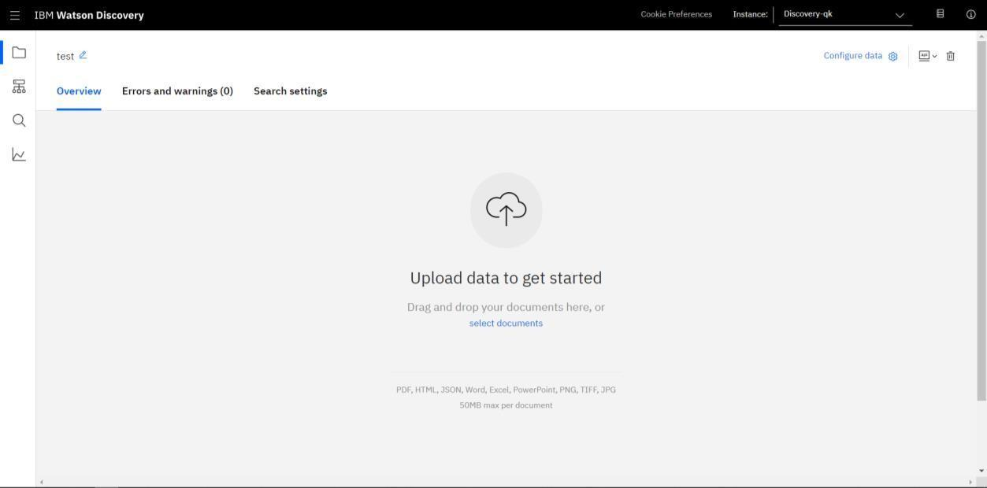

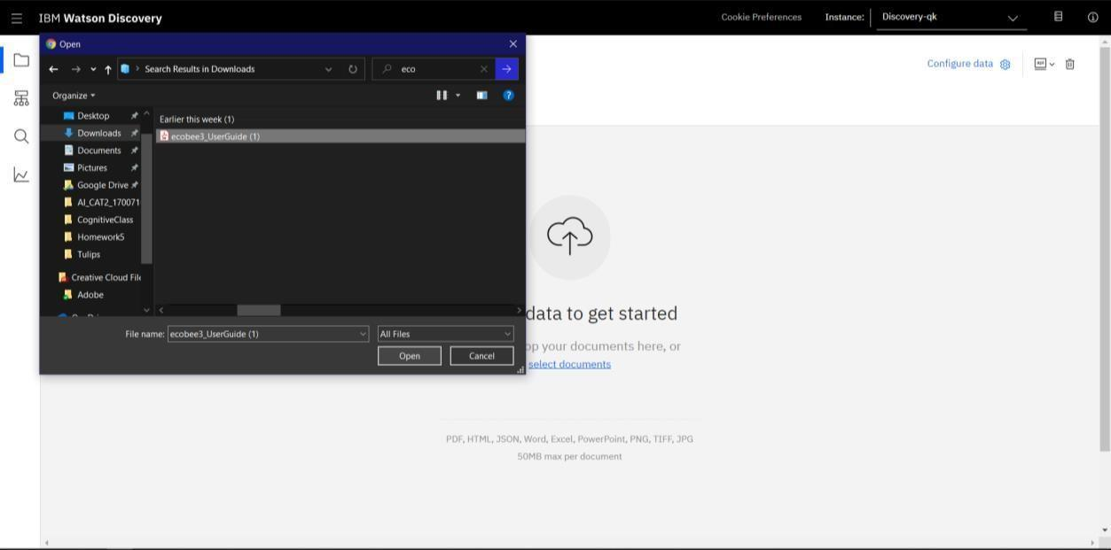

When prompted, select and upload the ecobee3_UserGuide.pdf file located in the data directory of your local repo.

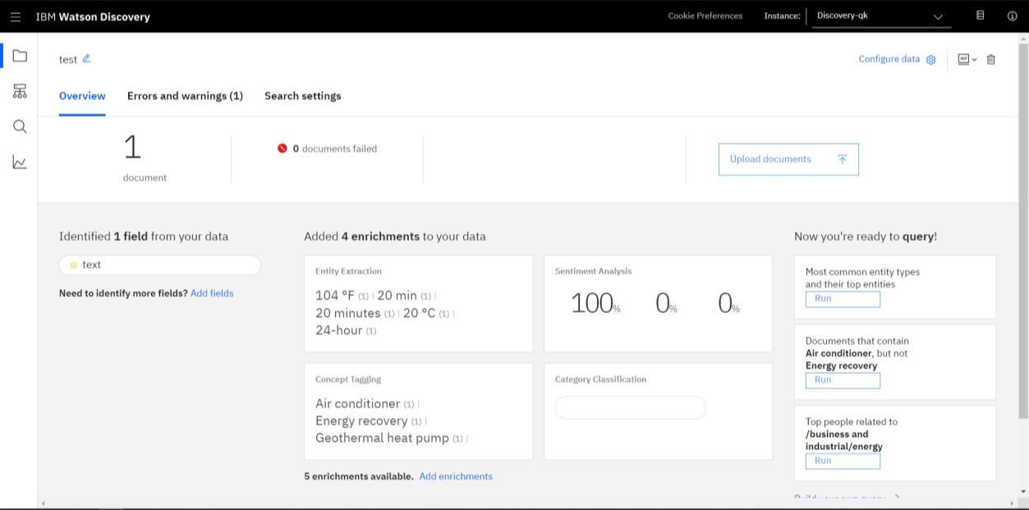

Before proceeding further, let’s learn about Smart Document Understanding(SDU)

SDU trains Watson Discovery to extract custom fields in your documents. Customizing how your documents are indexed into Discovery will improve the answers returned from queries.With SDU, you annotate fields within your documents to train custom conversion models. As you annotate, Watson is learning and will start predicting annotations. SDU models can also be exported and used on other collections.

Current document type support for SDU is based on your plan:

* + Lite plans: PDF, Word, PowerPoint, Excel, JSON, HTML
  + Advanced plans: PDF, Word, PowerPoint, Excel, PNG, TIFF, JPG, JSON, HTML

Before applying SDU to our document, let’s do some simple queries on the data so that we can compare it to results found after applying SDU.

Click on Build your own query.

Now, enter queries related to the operation of the thermostat and view the results. As you will see, the results are not very useful, and in some cases, not even related to the question.

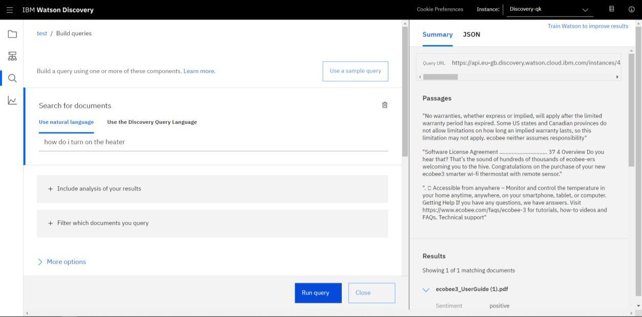

Now let's apply SDU to our document to see if we can generate some better query responses.

Go back to the Discovery collection panel (previous screen)

Click the Configure data button (located in the top right corner) to start the SDU process.

Here is the layout of the Identify fields tab of the SDU annotation panel

The goal is to annotate all of the pages in the document so Discovery can learn what text is important, and what text can be ignored.

1. is the list of pages in the manual. As each is processed, a green check mark will appear on the page.
2. is the current page being annotated.
3. is where you select text and assign it a label.
4. is the list of labels you can assign to the page text.

Click [5] to submit the page to Discovery.

As you go through the annotations one page at a time, Discovery is learning and should start automatically updating the upcoming pages. Once you get to a page that is already correctly annotated, you can stop, or simply click Submit [5] to acknowledge it is correct. The more pages you annotate, the better the model will be trained.

For this specific owner's manual, at a minimum, it is suggested to mark the following:

* + The main title page as title
  + The table of contents (shown in the first few pages) as table_of_contents
  + All headers and subheaders (typed in light green text) as a subtitle
  + All page numbers as footers
  + All warranty and licensing information (located in the last few pages) as a footer
  + All other text should be marked as text. After completing the process for all pages,

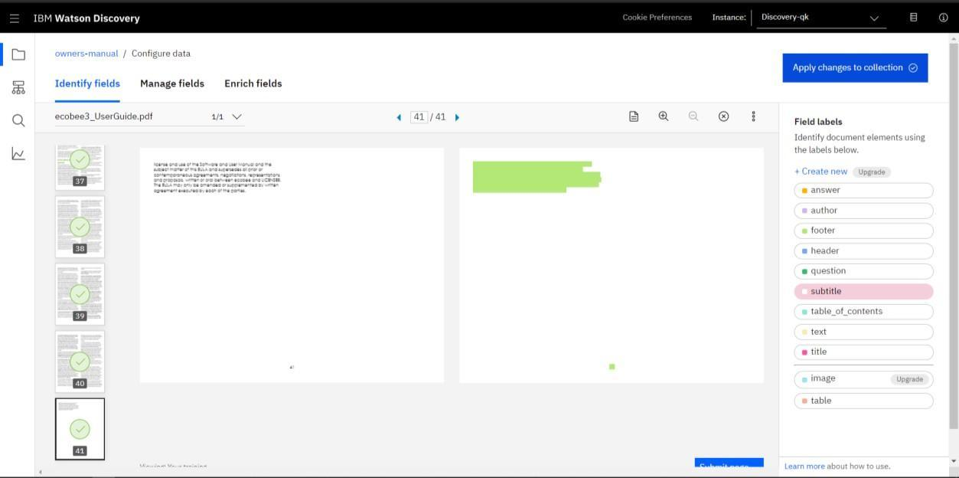

Click the 

You will be asked to reload the document. Choose the same ecobee3_UserGuide.pdf document as before.

Now, click on Manage fields tab on the Configure data panel

1. Here is where you tell Discovery which fields to ignore. Using the on/off buttons, turn off all labels except subtitles and text.
2. is telling Discovery to split the document apart, based on subtitles. Click [3] to submit your changes.

Once again, you will be asked to reload the document. Choose the same ecobee3_UserGuide .pdf document as before.

Now, as a result of splitting the document apart, your collection will look different

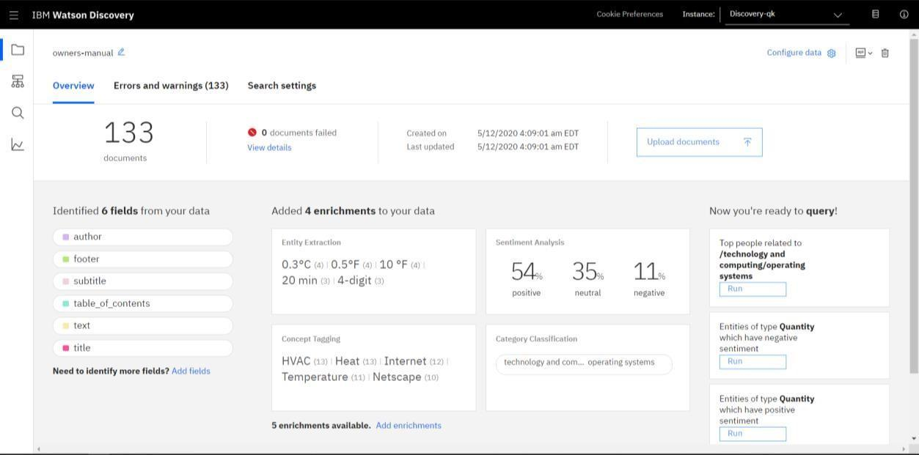

Now click the Build your own query and see how much better the results are.

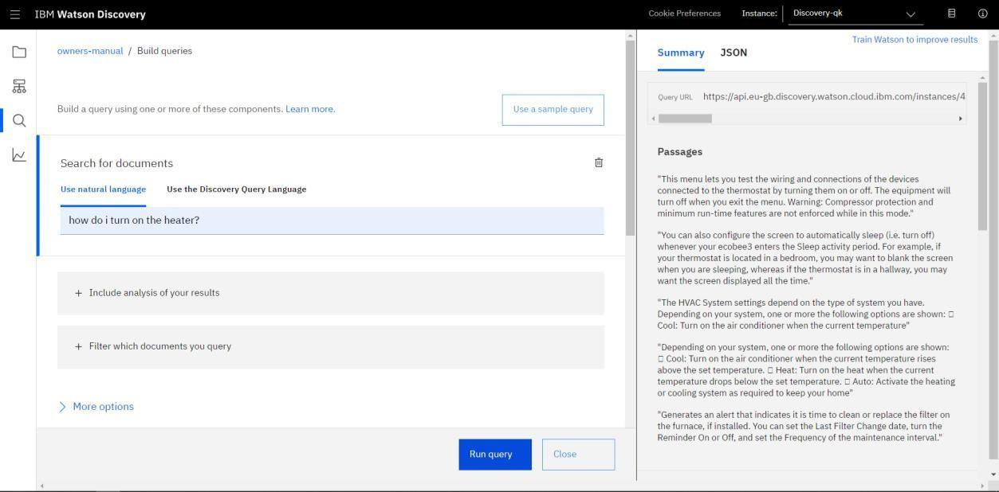

In upcoming steps, you will need to provide some credentials to access your Discovery collection so to Store credentials for future use follow the below steps.

The Collection ID and Environment ID values can be found by clicking the located at the top right side of your collection panel

Now go to the Watson Discovery Resource List Screen. Here, select service credentials.

The api key and URL endpoint for your service can be found here.

1. **Create IBM Cloud Functions action**

Now let's create the web action that will make queries against our Discovery collection.

Go to IBM Cloud Dashboard, click on Create Resource and search for Functions

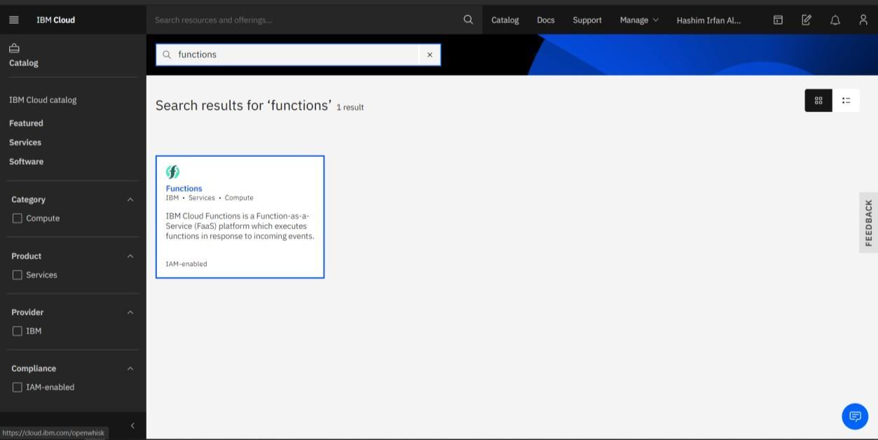

Select the Functions Card.

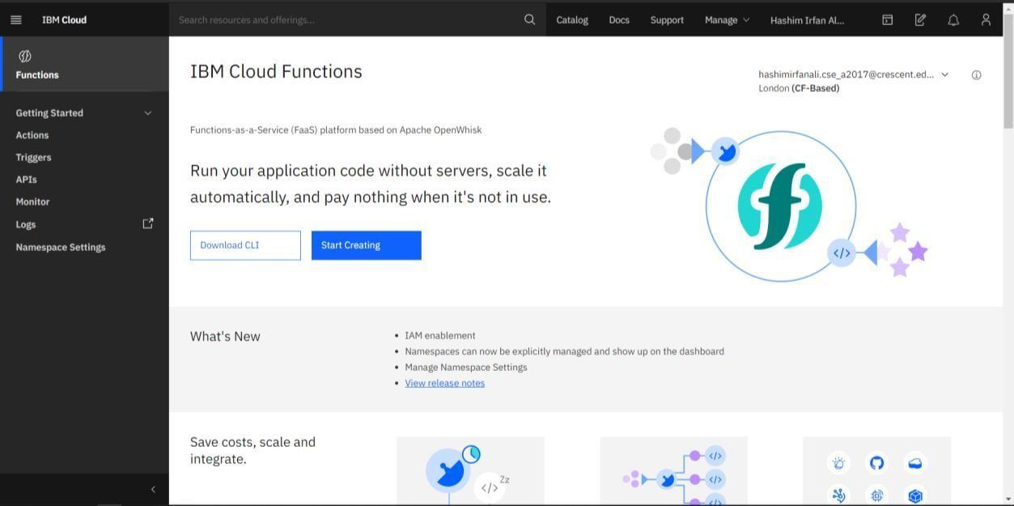

From the Functions main panel, click on Start Creating.

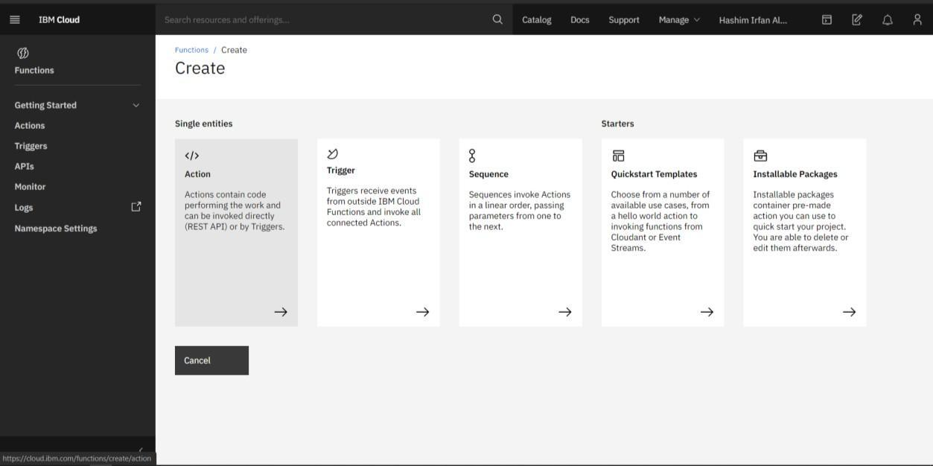

Here, select Actions.

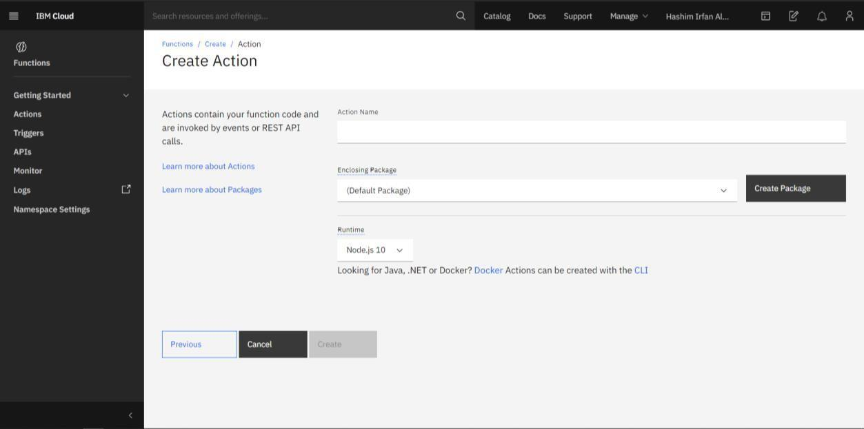

On the Create Action panel, provide a unique Action Name, keep the default package, and select the Node.js 10 runtime. Click the Create button to create the action.

Once the function is created, click on the code tab.

In the code editor window [1], cut and paste in the code from the disco-action.js file found in the actions directory of your local repo. The code is pretty straight-forward - it simply connects to the Discovery service, makes a query against the collection, then returns the response.

Now if I click the invoke [2] button, it will fail due to credentials not being defined yet.

To solve this, select parameter[1] tab

Add the following keys:

* + url
  + environment_id
  + collection_id
  + iam_apikey

For the above values, please use the values associated with the Discovery service you created in the previous step.Enclose your values in double quotes.

Now that the credentials are set, return to the Code panel tab and press the Invoke button again. Now you should see actual results returned from the Discovery service

Now click on endpoints[1] tab

Click the checkbox for Enable as Web Action [2]. This will generate a public endpoint URL [3].

Take note of the URL value [3], as this will be needed by Watson Assistant in a future step.

To verify you have entered the correct Discovery parameters, execute the provided curl command [4]. If it fails, re-check your parameter values.

[An IBM Cloud Functions service will not show up in your dashboard resource list. To return to your defined Action, you will need to access Cloud Functions by selecting Create Resource from the main dashboard panel (as shown at the beginning of this step).]

1. **Configure Watson Assistant**

Go back to the IBM Dashboard From the resource list screen, click to open Watson Assistant service.

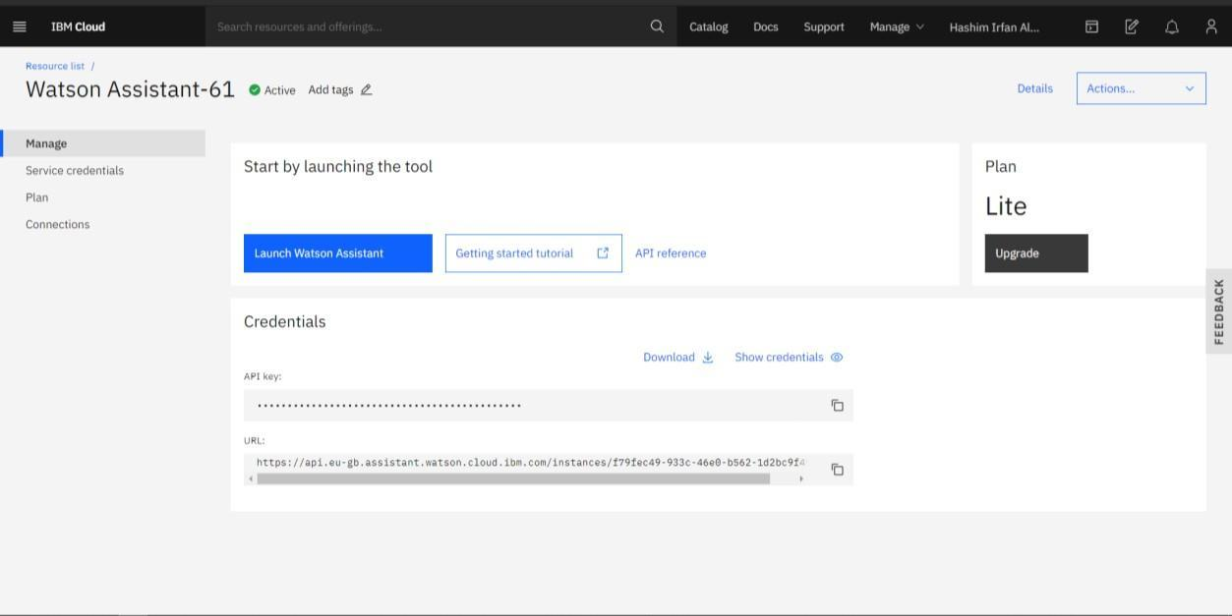

Click on to launch Watson Assistant.

Click on the skills tab

Click Create Skill

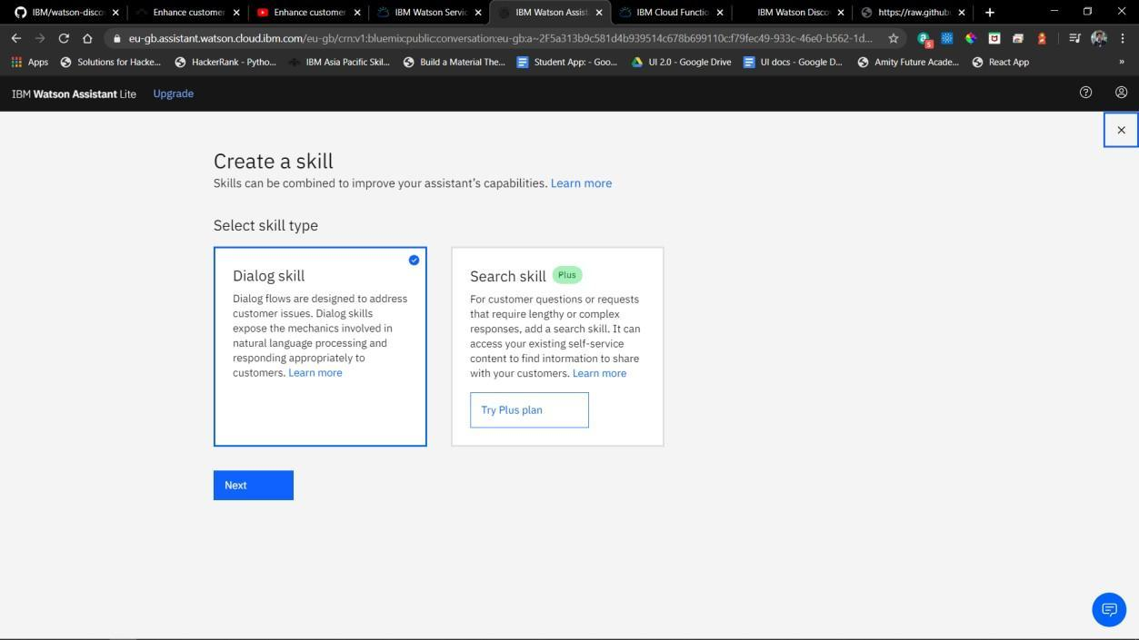

Select Dialog Skill Card and Click next

Select Use Sample Skill [1] and Select Customer Care Sample Skill [2]. This dialog skill contains all of the nodes needed to have a typical call centre conversation with a user.

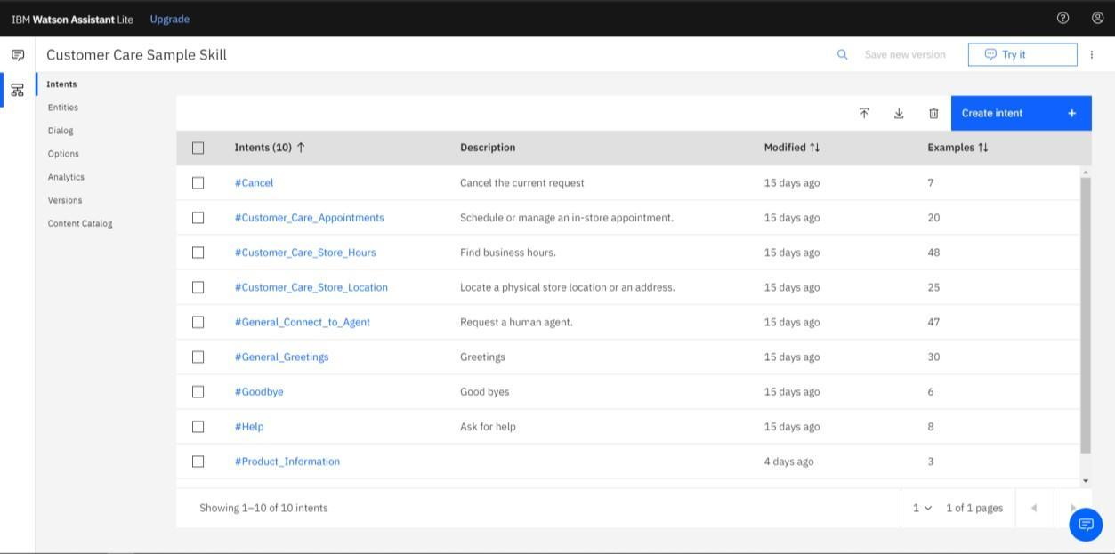

As the default customer care dialog does not have a way to deal with any questions involving outside resources, so we will need to add new intent.

Create a new intent that can detect when the user is asking about operating the Ecobee thermostat.

From the Customer Care Sample Skill panel, select the Intents tab. Click the Create intent button.

Name the intent #Product_Information, and at a minimum, enter the following example questions to be associated with it.

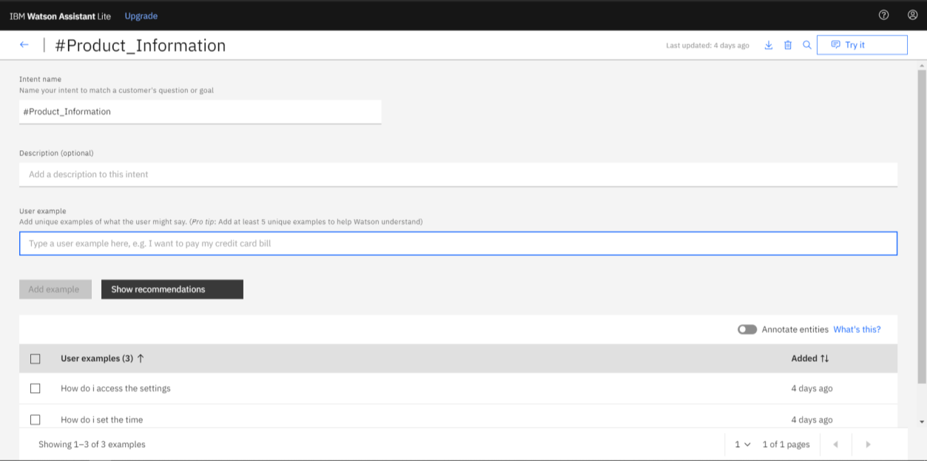

Go back to the previous page after doing this, then click on Dialog Tab and add a node below What can I do node.

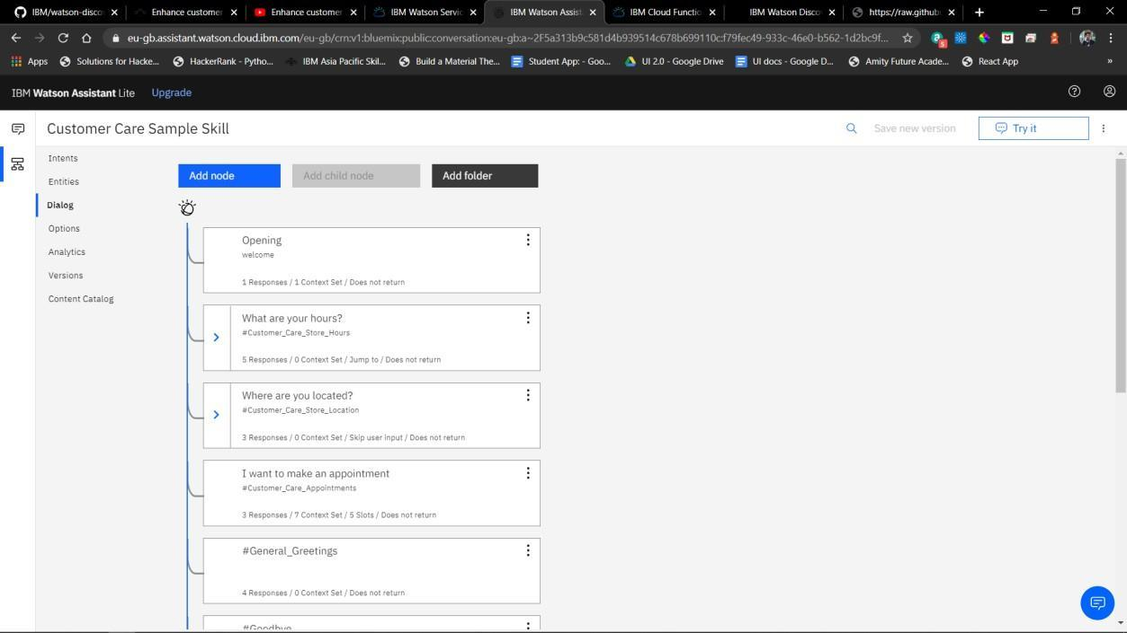

Name the node "Ask product information" [1] and assign it our new intent #Product_Information [2].

This means that if Watson Assistant recognizes a user input such as "how do I set the time?", it will direct the conversation to this node.

Before proceeding further, let’s learn about webhook.

A webhook is a mechanism that allows you to call out to an external program based on something happening in your program. When used in a Watson Assistant dialog skill, a webhook is triggered when the Assistant processes a node that has a webhook enabled. The webhook collects data that you specify or that you collect from the user during the conversation and save in context variables, and sends the data to the Webhook request URL as an HTTP POST request. The URL that receives the webhook is the listener. It performs a predefined action using the information that is provided by the webhook as specified in the webhook definition, and can optionally return a response.

In our example, the webhook will communicate with an IBM Cloud Functions web action, which is connected to the Watson Discovery service.

Click Webhooks[1] tab and enter the URL[2] to enable web hook for the IBM Cloud Functions action you created in Step 3.Add .json to the end of the URL to specify the result should be in JSON format.

Return to the Dialog tab, and click on the Ask product information node. From the details panel for the node, click on Customize, and enable Webhooks for this node

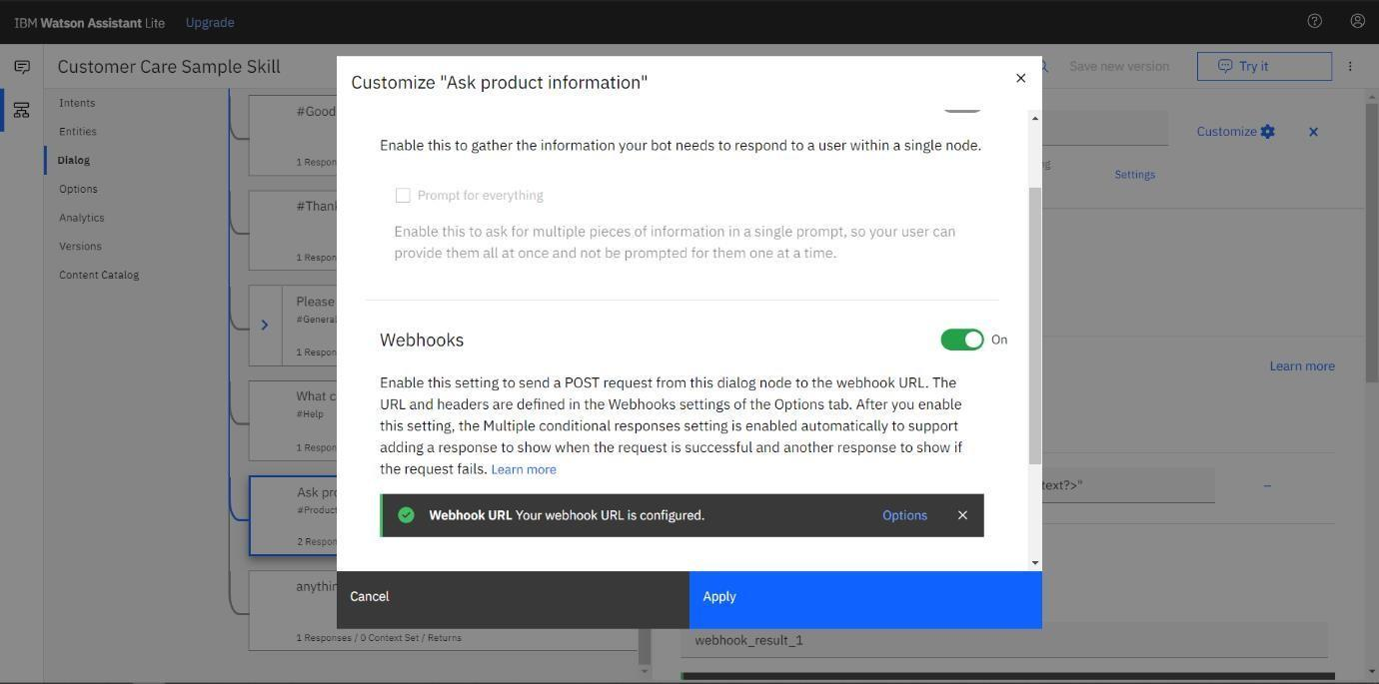

Click Apply.

The dialog node should have a Return variable [1] set automatically to

$webhook_result_1. This is the variable name you can use to access the result from the Discovery service query.

You will also need to pass in the users question via the parameter input [2]. The key needs to be set to the value:

"<?input.text?>"

If you fail to do this, Discovery will return results based on a blank query. Optionally, you can add these responses to aid in debugging:

Now we should test the assistant, from click the Try it button located at the top right side of the panel.

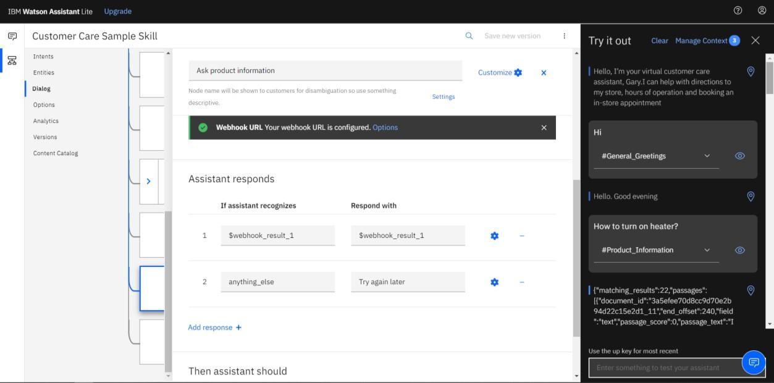

Note that the input "how do I turn on the heater?" has triggered our Ask about product dialog node, which is indicated by the #Product_Information response.

And because we specified that $webhook_result_1.passages be the response, that value is displayed also.

You can also verify that the call was successfully completed by clicking on the Manage Context button at the top right. The response from the Discovery query will be stored in the $webhook_result_1 variable

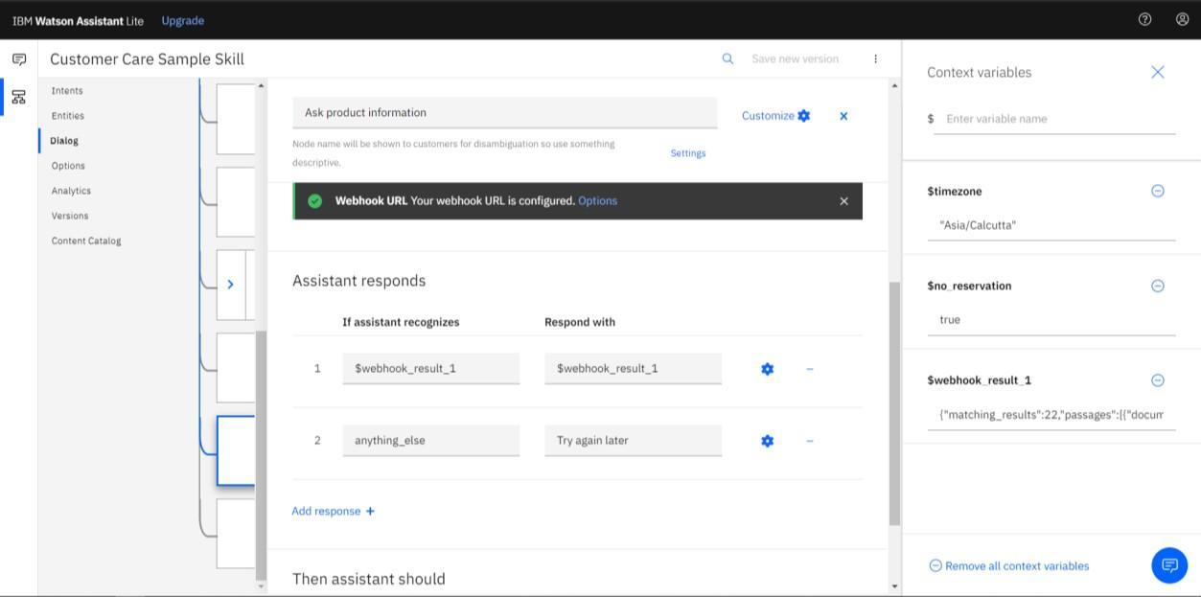

For upcoming steps, you will need to provide some credentials to access your assistant so to store credentials for future use follow these steps below.

Go back to the skills tab, click [1] and then [2]

The Skill ID and API Key is to be noted.

Go Back to the Watson Assistant Resource List, Select Service Credentials [1] and make note of the URL.API KEY can be found here too.

1. **Build Node-RED Flow to Integrate All Services**

Now it’s time to create Node-Red, go to IBM Cloud Dashboard, click on Create Resource and search for node-red[1].

Click on the Node-RED App tile [2].

This will show you an overview of the Starter Kit and what it provides.

Click on Create [1].

Now you need to configure the Node-RED Starter application.

On the App details page, a randomly generated name will be suggested – Node RED KBBI in the screenshot above. Either accept that default name or provide a unique name for your application [1]. This will become part of the application URL. Note: If the name is not unique, you will see an error message and you must enter a different name before you can continue.

The Node-RED Starter application requires an instance of the Cloudant database service to store your application flow configuration. To do this,

Select the region [1] the service should be created in and what pricing plan it should use. You can only have one Cloudant instance using the Lite plan and You can have more than one Node-RED Starter application using the same Cloudant service instance.

If you have already got an instance, you will be able to select it from the Pricing plan select box [2]. Click the Create button [3] to continue. This will create your application, but it is not yet deployed to IBM Cloud.

At this point, you have created the application and the resources it requires, but you have not deployed it anywhere to run, so this step shows how to set up the Continuous Delivery feature that will deploy your application into the Cloud Foundry space of IBM Cloud. Click on Deploy your App[1]

You will need to create an IBM Cloud API key to allow the deployment process to access your resources. Click the New button (1) to create the key. A message dialog will appear. Read what it says and then confirm and close the dialog.

After creating the API Key, Increase the Memory allocation per instance slider [1] to 256MB. If you do not increase the memory allocation, your Node-RED application might not have sufficient memory to run successfully. The Node-RED Starter kit only supports deployment to the Cloud Foundry space of IBM Cloud. Select the region [2] to deploy your application to. This should match the region you created your Cloudant instance in.Click Next [3].

Now, Select the region [1] to create the DevOps toolchain and then Click Create [2].

This will take you back to the application details page.

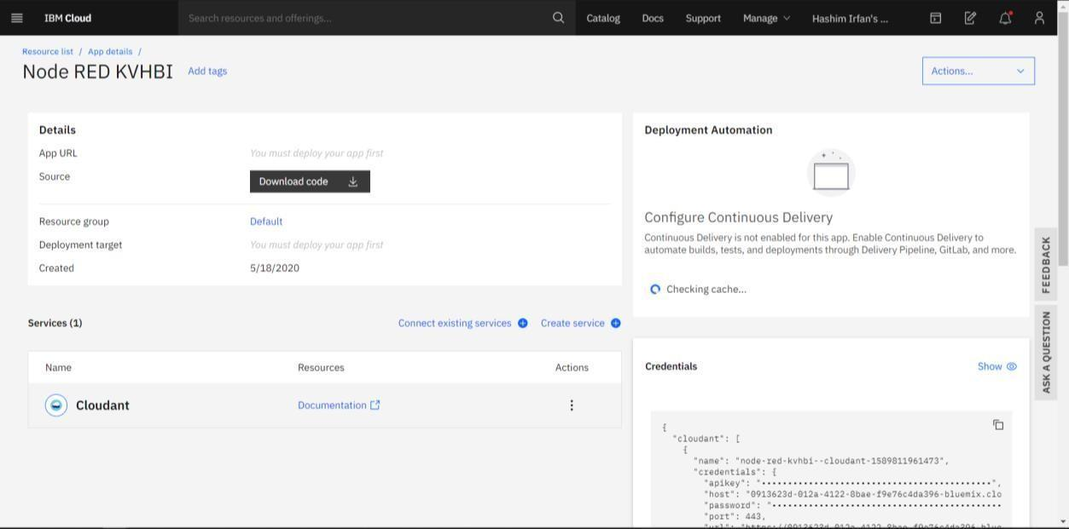

The Continuous Delivery section will refresh with the details of your newly created Toolchain. The Status field of the Delivery Pipeline will show In progress. That means your application is still being built and deployed.

The Deploy stage will take a few minutes to complete. Eventually the Deploy stage will go green to show it has passed. This means your Node-RED Starter application is now running.

Now that you’ve deployed your Node-RED application, let’s open it up! Open your IBM Cloud Resource list. You will see your newly created Node-RED Application listed under the Apps section [1]. You will also see a corresponding entry under the Cloud Foundry apps section [2].

Click on this Cloud Foundry app entry to go to your deployed application’s details page.

Special Cases: If your Runtime Instance is running full (0MB Free), Click on Edit[1] and reduce memory per instance to 128mb.

If you have Free space on your runtime skip the previous step[1] and Click on Visit App URL[2]

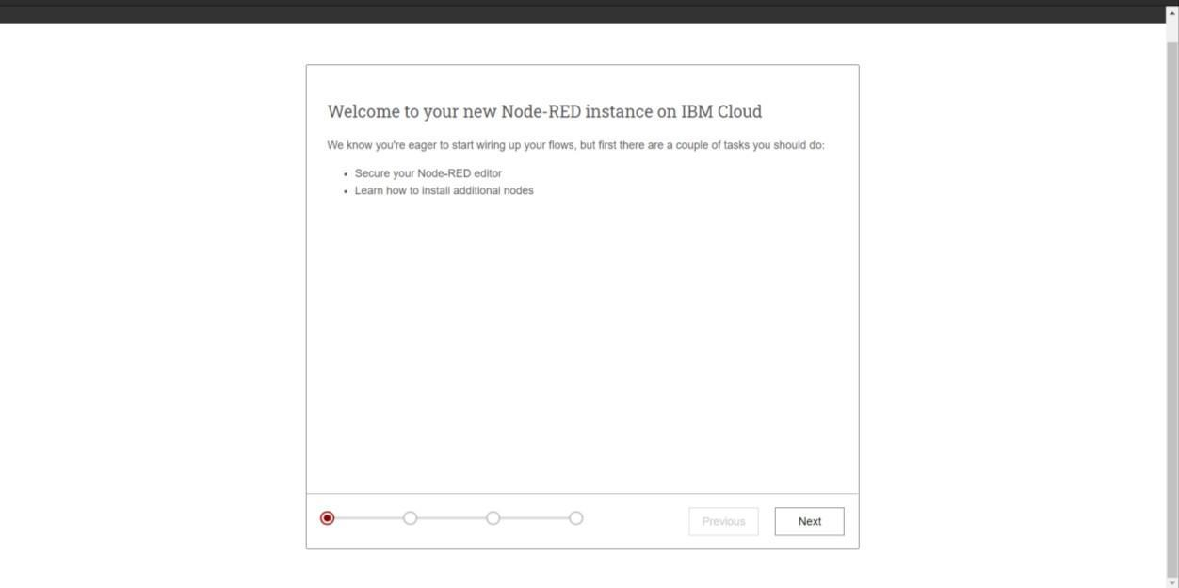

Click Next.

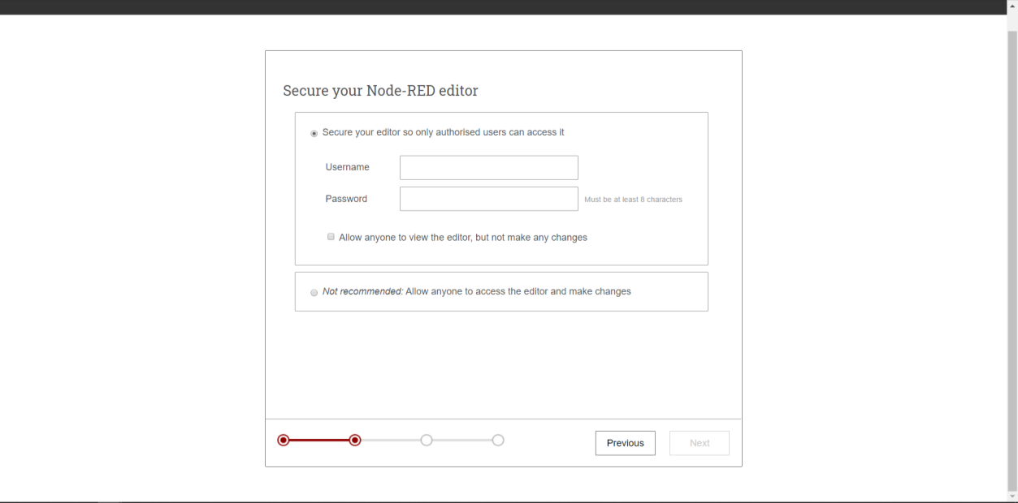

You can choose to Secure your Node-RED editor by providing a username and password. I am selecting the other option which is Allow anyone to access the editor and make changes.

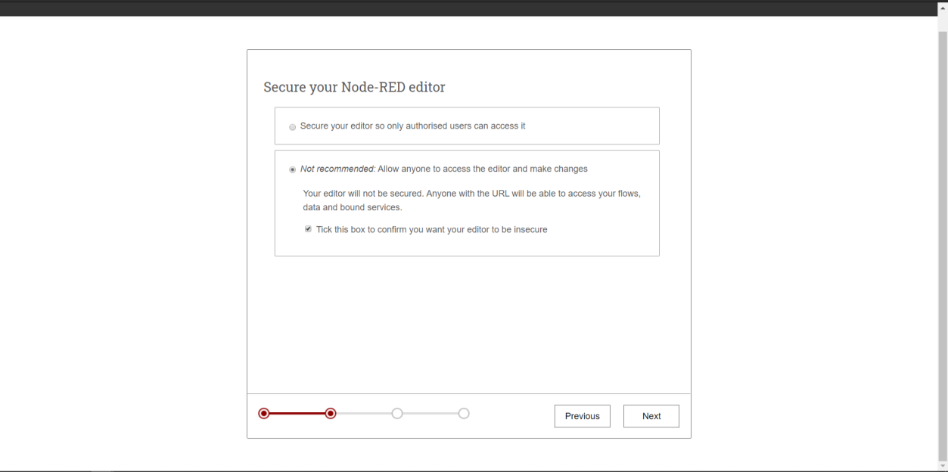

Tick the box, and click Next.

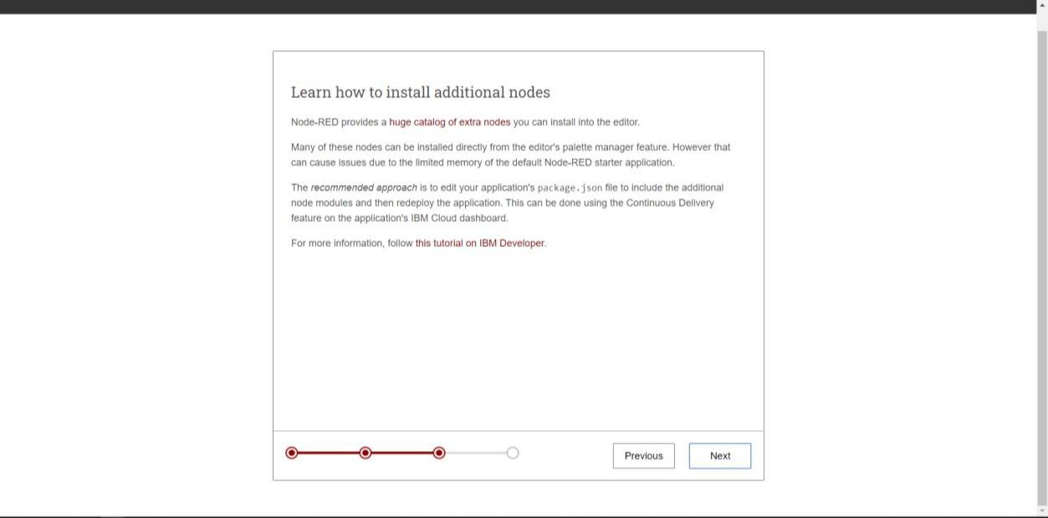

Click Next.

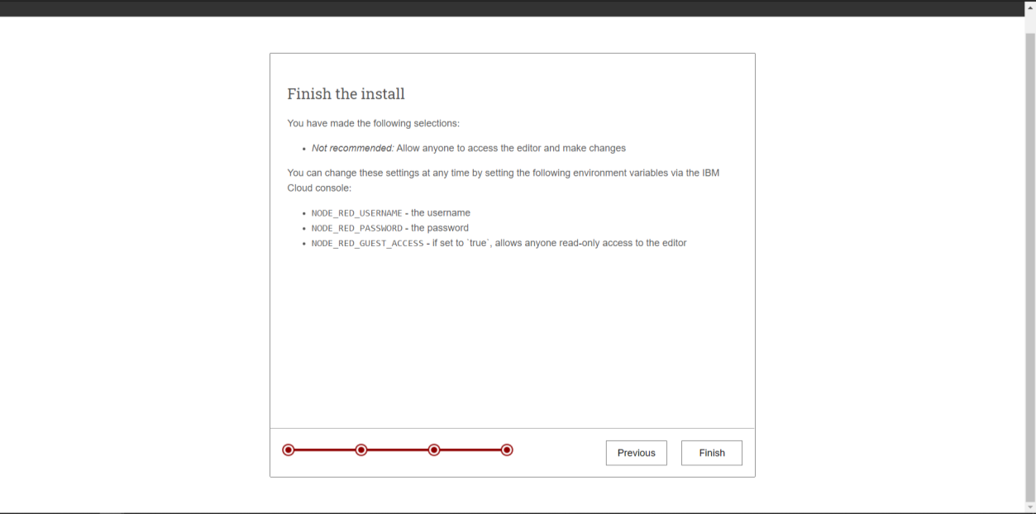

The final screen summarizes the options you’ve made and highlights the environment variables you can use to change the options in the future. Click Finish to proceed. Node-RED will save your changes and then load the main application.

From here you can click the Go to your Node-RED flow editor button to open the editor.

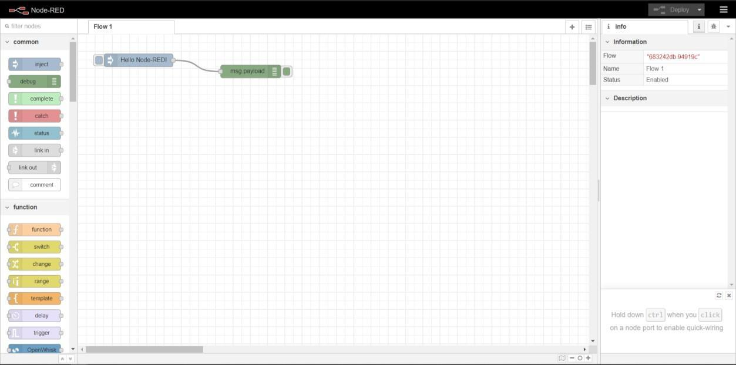

The Node-RED editor opens showing the default flow.

1. **Configure the nodes and Build A Web Dashboard in Node-RED**

To add Nodes to integrate Assistant, click [1] and then select Manage Palette [2]

Go to Install Tab [1] and search for node-red-dashboard and Install [2] it.

Using the nodes in the palette, Configure the required nodes and build web dashboard in Node-RED.

1. **Deploy and Run the application**

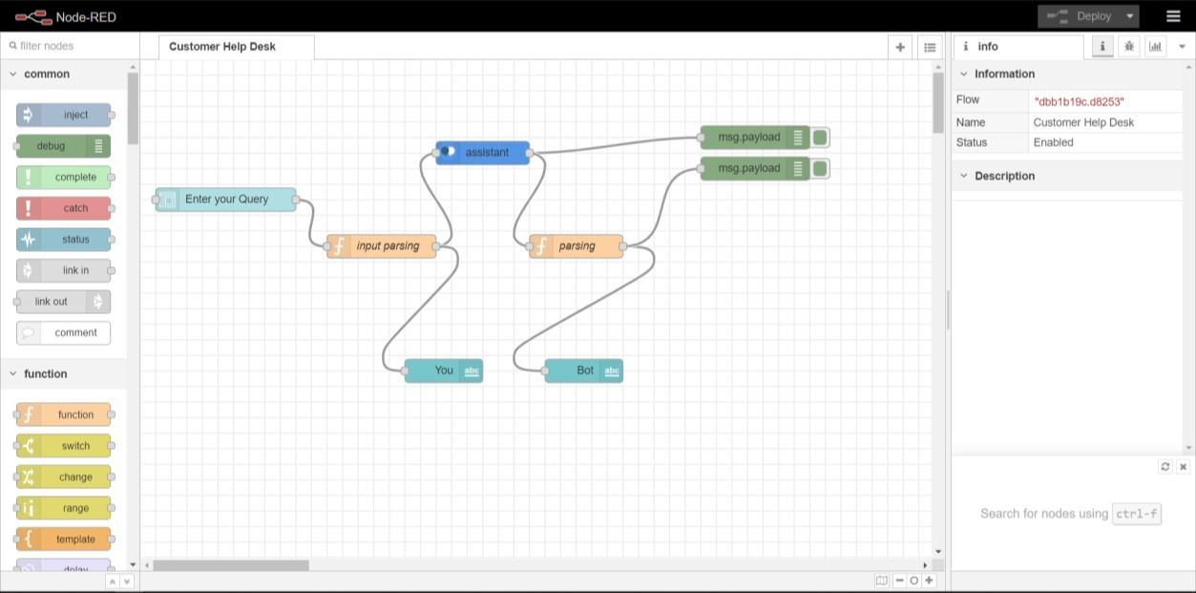

After Deploying the App, Run it.

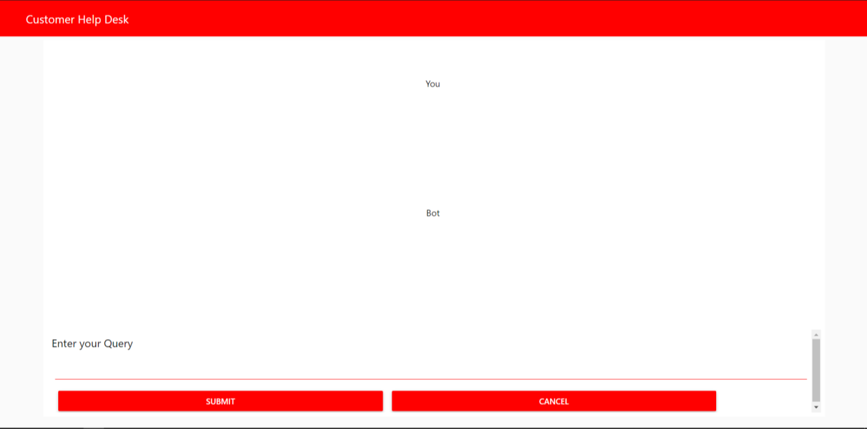

1. **FLOWCHART**

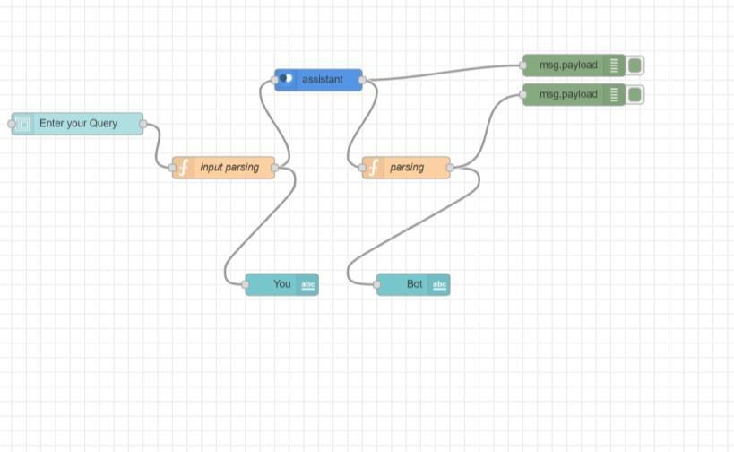

First, Add a Form Node. Connect it with a function node and name it input parsing. To that add a Text Node and name it You. To the input parsing node, add the assistant node.

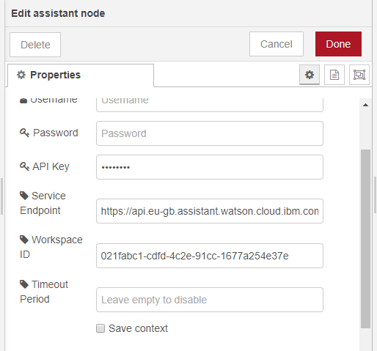

Enter the API Key, Service Endpoint (URL) and Workspace ID (Skill ID) from Step 4 and click Done. To the assistant node add debug node. Add another function node to the assistant node and name it parsing. Add text node to parsing node and name it Bot. Add another debug node to the parsing node.

For Function Node named input parsing, use the code below:

msg.payload=msg.payload.text; return msg;

For Function Node named parsing, use the code below:

msg.payload.text=""; if(msg.payload.context.webhook_result_1){

for(var i in msg.payload.context.webhook_result_1.results){

msg.payload.text=msg.payload.text+"\n"+msg.payload.context.webhook_result_1.re sults[i].text;

}

msg.payload=msg.payload.text;

}

else

msg.payload = msg.payload.output.text[0]; return msg;

1. **RESULT**

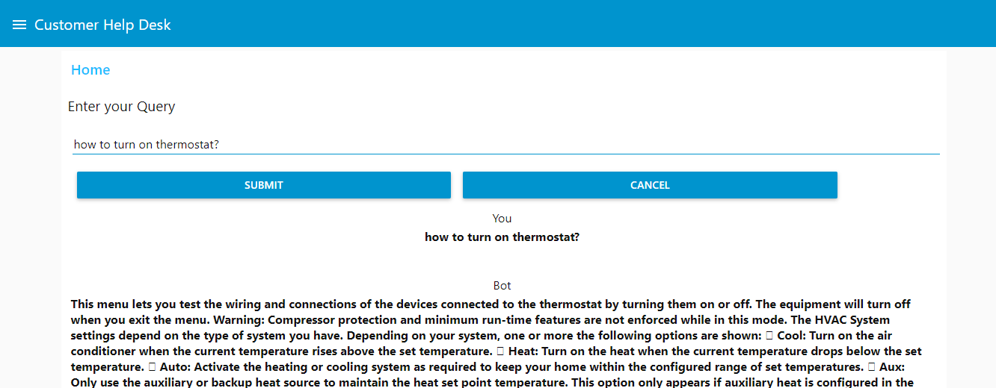

Chatbot Link:

<https://node-red-thcfp.eu-gb.mybluemix.net/ui/#!/1?socketid=NLS6DmkHxCLxA-pAAAA1>

Explanation Video Link:

https://youtu.be/gyeXRfuLgBo

1. **ADVANTAGES & DISADVANTAGES**

Advantages:

* + Faster Customer Service
  + Increased Customer Satisfaction
  + Lower Labour Costs
  + Variety of Uses
  + Data collection
  + 24-7 availability
  + Multiple Customer Handling

Disadvantages:

* + Limited Responses for Customers
  + Customers Could Become Frustrated
  + Maintenance
  + They aren’t human
  + Time-Consuming

1. **APPLICATIONS**

A Product or Software Company Customer Help Desk

1. **CONCLUSION**

An Intelligent Customer Helpdesk with Smart Document Understanding is made using various IBM Services like IBM Watson Discovery, IBM Watson and IBM Cloud Function.

1. **FUTURE SCOPE**

A More Human Friendly Chatbot, or a personalized Chatbot is to be expected.

1. **BIBILOGRAPHY APPENDIX**
2. Source Code

disco_action.js(Cloud Function Code)

/**

*

* @param {object} params
* @param {string} params.iam_apikey
* @param {string} params.url
* @param {string} params.username
* @param {string} params.password
* @param {string} params.environment_id
* @param {string} params.collection_id
* @param {string} params.configuration_id
* @param {string} params.input

*

* @return {object}

*

*/

const assert = require('assert');

const DiscoveryV1 = require('watson-developer-cloud/discovery/v1');

/**

*

* main() will be run when you invoke this action

*

* @param Cloud Functions actions accept a single parameter, which must be a JSON object.

*

* @return The output of this action, which must be a JSON object.

*

*/

function main(params) {

return new Promise(function (resolve, reject) { let discovery;

if (params.iam_apikey){ discovery = new DiscoveryV1({

'iam_apikey': params.iam_apikey, 'url': params.url,

'version': '2019-03-25'

});

}

else {

discovery = new DiscoveryV1({ 'username': params.username, 'password': params.password, 'url': params.url, 'version': '2019-03-25'

});

}

discovery.query({

'environment_id': params.environment_id, 'collection_id': params.collection_id, 'natural_language_query': params.input, 'passages': true,

'count': 3,

'passages_count': 3

}, function(err, data) { if (err) {

return reject(err);

}

return resolve(data);

});

});

}

## skill-Customer-Care-Sample-Skill.json (Watson Assistant Skill Code)

{

"intents": [

{

"intent": "General_Greetings", "examples": [

{

"text": "Good morning"

},

{

"text": "Good day"

},

{

"text": "hiya"

},

{

"text": "yo"

},

{

"text": "How are things going?"

},

{

"text": "How are you today?"

},

{

"text": "How have you been?"

},

{

"text": "hi"

},

{

"text": "How r u?"

},

{

"text": "Looking good eve"

},

{

"text": "Hey how are you doing"

|  |  |  |  |  |
| --- | --- | --- | --- | --- |
| }, |  | | | |
| { |
| "text": | "Hello I am looking for | some | help | here" |
| }, |  |  | | |
| { |  |
| "text": | "Hello" |
| }, |  |
| { |  |
| "text": | "Hello Agent" |
| }, |  |
| { |  |
| "text": | "Have you been well?" |
| }, |  |
| { |  |
| "text": | "Greetings" |
| }, |  |
| { |  |
| "text": | "Good to see you" |
| }, |  |
| { |  |
| "text": | "Good evening" |
| }, |  |
| { |  |
| "text": | "Hey you" |
| }, |  |
| { |  |
| "text": | "How is it going?" |
| }, |  |
| { |  |
| "text": | "You there" |
| }, |  |
| { |  |
| "text": | "Who is this?" |
| }, |  |
| { |  |
| "text": | "What's up?" |
| }, |  |
| { |  |
| "text": | "What's new?" |
| }, |  |
| { |  |
| "text": | "Hi there" |
| }, |  |
| { |  |
| "text": | "Hey twin" |
| }, |  |
| { |  |
| "text": | "Hi advisor" |
| }, |  |
| { |  |
| "text": | "Ok take me back" |
| }, |  |
| { |  |
| "text": | "Hey there" |
| }, |  |
| { |  |
| "text": | "Hey there all" |
| } |  |
| ], |  |

"description": "Greetings"

},

{

"intent": "Help", "examples": [

{

"text": "what can i say"

},

{

"text": "can you help"

},

{

"text": "can you assist me"

},

{

"text": "help"

},

{

"text": "help me decide"

},

{

"text": "help me"

},

{

"text": "i need assistance"

},

{

"text": "what can i do"

}

],

"description": "Ask for help"

},

{

"intent": "Customer_Care_Store_Hours",

|  |  |  |
| --- | --- | --- |
| "examples": | | [ |
| { | |  |
| "text": | | "what are your hours" |
| }, | |  |
| { | |  |
| "text": | | "will you open for christmas" |
| }, | |  |
| { | |  |
| "text": | | "will you be open Memorial day" |
| }, | |  |
| { | |  |
| "text": | | "when do you close" |
| }, | |  |
| { | |  |
| "text": | | "What time do you close" |
| }, | |  |
| { | |  |
| "text": | | "What time do you open on Saturdays" |
| }, | |  |
| { | |  |
| "text": | | "what time do you close on Sunday" |
| }, | |  |
| { | |  |
| "text": | | "What time do you close today" |
| }, | |  |
| { | |  |
| "text": | | "Hours of operation" |
| }, | |  |
| { | |  |
|  | "text": | "how late are you open" | |
|  | }, |  | |
|  | { |  | |
|  | "text": | "Are you open on Sunday" | |
|  | }, |  | |
|  | { |  | |
|  | "text": | "how late are you open tonight" | |
|  | }, |  | |
|  | { |  | |
|  | "text": | "are stores open on sunday" | |
|  | }, |  | |
|  | { |  | |
|  | "text": | "store open now" | |
|  | }, |  | |
|  | { |  | |
|  | "text": | "open hours store" | |
|  | }, |  | |
|  | { |  | |
|  | "text": | "when do your stores open" | |
|  | }, |  | |
|  | { |  | |
|  | "text": | "when does the store close" | |
|  | }, |  | |
|  | { |  | |
|  | "text": | "when can i visit your store" | |
|  | }, |  | |
|  | { |  | |
|  | "text": | "store hrs" | |
|  | }, |  | |
|  | { |  | |
|  | "text": | "store hours" | |
|  | }, |  | |
|  | { |  | |
|  | "text": | "store open" | |
|  | }, |  | |
|  | { |  | |
|  | "text": | "store open hours?" | |
|  | }, |  | |
|  | { |  | |
|  | "text": | "What is the opening time for the washington store?" | |
|  | }, |  | |
|  | { |  | |
|  | "text": | "Are you closing early today" | |
|  | }, |  | |
|  | { |  | |
|  | "text": | "Are you closed new Year's eve" | |
|  | }, |  | |
|  | { |  | |
|  | "text": | "how early do you open on Saturdays" | |
|  | }, |  | |
|  | { |  | |
|  | "text": | "how late are you there" | |
|  | }, |  | |
|  | { |  | |
|  | "text": | "how late y'all stay up till" | |
|  | }, |  | |
|  | { |  | |
|  | "text": | "will you open on christmas" | |
|  | }, |  | |
|  | { |  | |
|  | "text": | "Are the stores open early?" | |

|  |  |
| --- | --- |
| }, |  |
| { |
| "text": | "Are you open during thanksgiving?" |
| }, |  |
| { |  |
| "text": | "Are you open on bank holidays?" |
| }, |  |
| { |  |
| "text": | "Are you open on sundays, and if so what are the hours?" |
| }, |  |
| { |  |
| "text": | "At what hour can I swing by?" |
| }, |  |
| { |  |
| "text": | "Can you tell me how late the stores are open till?" |
| }, |  |
| { |  |
| "text": | "Does the store in the city center opens till 8pm on |
| weekends?" |  |
| }, |  |
| { |  |
| "text": | "How early do you open?" |
| }, |  |
| { |  |
| "text": | "How long are you open?" |
| }, |  |
| { |  |
| "text": | "Is the branch open now?" |
| }, |  |
| { |  |
| "text": | "What are the business hours of the store nearest to me?" |
| }, |  |
| { |  |
| "text": | "What are the hours of operation?" |
| }, |  |
| { |  |
| "text": | "What are the saturday opening times for the local |
| store?" |  |
| }, |  |
| { |  |
| "text": | "What are ur opening hours?" |
| }, |  |
| { |  |
| "text": | "What are your hous?" |
| }, |  |
| { |  |
| "text": | "What time are you closing today?" |
| }, |  |
| { |  |
| "text": | "What time does the central manchester store shut on a |
| saturday?" |  |
| }, |  |
| { |  |
| "text": | "What time do stores close?" |
| }, |  |
| { |  |
| "text": | "What time is your store open on saturday?" |
| } |  |
| ], |  |

"description": "Find business hours."

},

{

"intent": "Product_Information", "examples": [

{

"text": "How do i turn on the heater"

},

{

"text": "How do i set the time"

},

{

"text": "How do i access the settings"

}

],

"description": ""

},

{

"intent": "Customer_Care_Appointments", "examples": [

{

"text": "I prefer a face to face visit"

},

{

"text": "meet in store"

},

{

"text": "I want to talk in person with someone about my case"

},

{

"text": "I would like to discuss my situation face to face"

},

{

"text": "I would like to make an appointment to visit the nearest store to my location."

},

{

"text": "Could I speak to someone in the store next tuesday?"

},

{

"text": "Can I book an in person session"

},

{

"text": "are you available on tuesday"

},

{

"text": "can i book for tonight"

},

{

"text": "do you have availability next week"

},

{

"text": "can i make an appointment"

},

{

"text": "can you make an appointment for me"

},

{

"text": "i'd like to make an appointment"

},

{

"text": "What time can I meet the staff?"

},

{

store?"

"text": "When can I meet with one of your employees at your

},

{

"text": "Want to change my visit"

},

{

"text": "Store appointment"

},

{

"text": "Set up an appt"

},

{

"text": "Make an appointment"

},

{

"text": "i'd like to come in for an appointment"

}

],

"description": "Schedule or manage an in-store appointment."

},

{

"intent": "General_Connect_to_Agent", "examples": [

{

"text": "I want an agent to help me"

},

{

"text": "I want a manager"

},

{

"text": "I want agent"

},

{

"text": "I need to speak to a representative. How would I go about doing so?"

},

{

"text": "Is there anyone there I can actually talk to for real?"

},

{

"text": "I don't want to talk to you"

},

{

"text": "I don't want to talk to a bot."

},

{

"text": "How can I skip the recorded menu and go straight to a live person?"

},

{

"text": "Hi can you transfer me"

},

{

"text": "Do not want a robot?"

},

{

"text": "Customer service representative please."

},

{

"text": "Could you please transfer me to your master?"

},

{

"text": "Contact person"

},

{

"text": "Connect me to a live operator please."

},

{

"text": "Can you connect me with a real person?"

},

{

"text": "Can you assist me to connect to an agent?"

},

{

"text": "Can I talk to someone?"

},

{

"text": "Can I speak with somebody?"

},

{

"text": "Can I speak to an advisor?"

},

{

"text": "Can I speak to a live person?"

},

{

"text": "I dont want to talk to a computer"

},

{

"text": "call the manager"

},

{

"text": "I want to speak to a human"

},

{

"text": "I want to talk to the manager"

},

{

"text": "A real agent, please."

},

{

"text": "Call agent"

},

{

"text": "Agent help"

},

{

"text": "talk to a human"

},

{

"text": "Yes, take me to a real person"

},

{

"text": "Where is the closest agent?"

},

{

"text": "Send me to an agent"

},

{

"text": "I don't want to speak with a robot"

},

{

"text": "get me a person"

},

{

"text": "Can I connect to an agent?"

},

{

"text": "Can I speak to a human please?"

},

{

"text": "I want to speak to a person"

},

{

"text": "representative"

},

{

"text": "Put me through to someone"

},

{

"text": "Pls connect"

},

{

"text": "Please let me talk to a human being."

},

{

"text": "Please connect me to a live agent"

},

{

"text": "Operator please"

},

{

"text": "Please assist me to get to an agent"

},

{

"text": "Need help from human"

},

{

"text": "I would like to speak to someone"

},

{

"text": "I would like to speak to a human"

},

{

"text": "I want to talk to a person"

}

],

"description": "Request a human agent."

},

{

"intent": "Thanks", "examples": [

{

"text": "thx"

},

{

"text": "thank you very much"

},

{

"text": "that's nice of you"

},

{

"text": "many thanks"

|  |  |
| --- | --- |
| }, |  |
| { |
| "text": | "much appreciated" |
| }, |  |
| { |  |
| "text": | "i appreciate it" |
| }, |  |
| { |  |
| "text": | "thank you" |
| }, |  |
| { |  |
| "text": | "thanks" |
| } |  |

],

"description": "Thanks"

},

{

"intent": "Goodbye", "examples": [

{

"text": "so long"

},

{

"text": "good bye"

},

{

"text": "see ya"

},

{

"text": "arrivederci"

},

{

"text": "ciao"

},

{

"text": "bye"

}

],

"description": "Good byes"

},

{

"intent": "Cancel", "examples": [

{

"text": "forget it"

},

{

"text": "never mind"

},

{

"text": "cancel that"

},

{

"text": "i changed my mind"

},

{

"text": "cancel the request"

},

{

"text": "i don't want a table anymore anymore"

},

{

"text": "nevermind"

}

],

"description": "Cancel the current request"

},

{

"intent": "Customer_Care_Store_Location", "examples": [

{

"text": "where are you"

},

{

"text": "what is the address"

},

{

"text": "how do i find you"

},

{

"text": "location please"

},

{

"text": "can you give me directions"

},

{

"text": "where are you located"

},

{

"text": "how do i get to your place"

},

{

"text": "Find store"

},

{

"text": "Where is?"

},

{

"text": "Where are you located?"

},

{

"text": "how do i get to your business"

},

{

"text": "Go to your company"

},

{

"text": "I'd like to go to a store"

},

{

"text": "I need help with find a store"

},

{

"text": "I want to know about a store"

},

{

"text": "Looking for a location"

},

{

"text": "What is the closest store to my address?"

},

{

"text": "What is the nearest branch?"

},

{

"text": "What is the store near my zip code?"

},

{

"text": "what's your location"

},

{

"text": "give me directions"

},

{

"text": "which cross streets are you on"

},

{

"text": "how can i get to you from grand central"

},

{

"text": "please suggest route from times square"

},

{

"text": "Where is your office?"

}

],

"description": "Locate a physical store location or an address."

}

],

"entities": [

{

"entity": "sys-number",

"values": []

},

{

"entity": "sys-time",

"values": []

},

{

"entity": "reply", "values": [

{

"type": "synonyms",

"value": "yes", "synonyms": [

"definitely", "go for it", "let's do it",

"ok",

"please",

"sure",

"why not",

"yeah",

"yes",

"you bet", "you betcha", "yep"

]

},

{

"type": "synonyms",

"value": "no", "synonyms": [

"definitely not", "don't think so", "dont think so", "i think not", "nope",

"not at this time", "not now"

]

}

]

},

{

"entity": "landmark", "values": [

{

"type": "synonyms", "value": "grand central", "synonyms": []

},

{

"type": "synonyms",

"value": "empire state building", "synonyms": [

"empire state", "emprire state"

]

},

{

"type": "synonyms", "value": "times square", "synonyms": [

"time sqaure", "time square", "times sqaure"

]

}

],

"fuzzy_match": true

},

{

"entity": "holiday", "values": [

{

"type": "synonyms", "value": "christmas eve", "synonyms": [

"x mas eve", "x-mas eve", "xmas eve"

]

},

{

"type": "synonyms",

"value": "labor day",

"synonyms": []

},

{

"type": "synonyms", "value": "independence day",

"synonyms": [

"7/4",

"fourth of july", "july 4",

"july 4th", "july fourth"

]

},

{

"type": "synonyms", "value": "valentine's day", "synonyms": [

"valentine day", "valentines day"

]

},

{

"type": "synonyms", "value": "memorial day", "synonyms": []

},

{

"type": "synonyms", "value": "thanksgiving", "synonyms": [

"turkey day"

]

},

{

"type": "synonyms", "value": "christmas", "synonyms": [

"christmas day", "x man day", "xmas",

"x mas",

"x-mas",

"x-mas day", "xmas day"

]

},

{

"type": "synonyms", "value": "halloween", "synonyms": []

},

{

"type": "synonyms",

"value": "new years", "synonyms": [

"1/1",

"jan 1",

"jan 1st", "jan first", "january 1", "january 1st",

"january first", "new year",

"new year day", "new years day"

]

},

{

"type": "synonyms", "value": "new years eve", "synonyms": [

"12-31",

"12/31",

"dec 31", "dec 31st",

"new year's eve"

]

}

]

},

{

"entity": "specialist", "values": [

{

"type": "synonyms",

"value": "Robert", "synonyms": [

"bob"

]

},

{

"type": "synonyms",

"value": "Brenda",

"synonyms": []

},

{

"type": "synonyms",

"value": "Maria",

"synonyms": []

},

{

"type": "synonyms",

"value": "Derrik", "synonyms": [

"derrick", "derek",

"derik", "derrik"

]

},

{

"type": "synonyms",

"value": "Nicholas", "synonyms": [

"nick"

]

},

{

"type": "synonyms",

"value": "Barbara", "synonyms": [

"barbra"

]

}

]

},

{

"entity": "phone", "values": [

{

"type": "patterns",

"value": "US Phone pattern", "patterns": [

"(\\d{3})-(\\d{3})-(\\d{4})"

]

}

]

},

{

"entity": "zip_code", "values": [

{

"type": "patterns",

"value": "US Zip", "patterns": [

"(\\b|\\s)\\d{5}(\\b|\\s)"

]

}

]

},

{

"entity": "sys-date",

"values": []

}

],

"metadata": { "api_version": {

"major_version": "v2", "minor_version": "2018-11-08"

}

},

"webhooks": [

{

"url": "https://us-south.functions.cloud.ibm.com/api/v1/web/728c6dcb- 3bf4-4108-b946-4e5cc6fc84d6/default/disco_action.json",

"name": "main_webhook", "headers": []

}

],

"dialog_nodes": [

{

"type": "response_condition", "output": {

"generic": [

{

"values": [

{

"text": "Try again later"

}

],

"response_type": "text", "selection_policy": "sequential"

}

]

},

"parent": "node_8_1589275295349", "conditions": "anything_else", "dialog_node": "response_2_1589275317844",

"previous_sibling": "response_4_1589275315523"

},

{

"type": "response_condition", "output": {

"generic": [

{

"values": [

{

"text": "$webhook_result_1"

}

],

"response_type": "text", "selection_policy": "sequential"

}

]

},

"parent": "node_8_1589275295349", "conditions": "$webhook_result_1", "dialog_node": "response_4_1589275315523"

},

{

"type": "event_handler", "output": {},

"parent": "slot_22_1522444583114", "context": {

"phone": "@phone"

},

"metadata": {}, "conditions": "@phone", "event_name": "input",

"dialog_node": "handler_23_1522444583114", "previous_sibling": "handler_24_1522444583114"

},

{

"type": "event_handler", "output": {

"text": {

"values": [ "Thanks"

],

"selection_policy": "sequential"

}

},

"parent": "slot_22_1522444583114", "context": {},

"metadata": {}, "conditions": "true", "event_name": "filled",

"dialog_node": "handler_22_1522598191131", "previous_sibling": "handler_23_1522444583114"

},

{

"type": "event_handler", "output": {

"text": "I'll just need a phone to hold your reservation"

},

"parent": "slot_22_1522444583114", "metadata": {},

"event_name": "focus",

"dialog_node": "handler_24_1522444583114"

},

{

"type": "event_handler", "output": {},

"parent": "slot_8_1509132875735", "context": {

"confirm": "@reply && slot_in_focus"

},

"metadata": {},

"conditions": "@reply && slot_in_focus", "event_name": "input",

"dialog_node": "handler_9_1509132875735", "previous_sibling": "handler_10_1509132875735"

},

{

"type": "event_handler", "output": {

"text": {

"values": [ "Perfect!"

]

}

},

"parent": "slot_8_1509132875735", "metadata": {},

"conditions": "@reply:yes", "event_name": "filled",

"dialog_node": "handler_14_1509133469904", "previous_sibling": "handler_9_1509132875735"

},

{

"type": "event_handler", "output": {

"text": {

"values": [

"Sorry... let's try again"

]

}

},

"parent": "slot_8_1509132875735", "context": {

"date": null,

"time": null, "confirm": null

},

"metadata": {}, "conditions": "@reply:no", "event_name": "filled",

"dialog_node": "handler_17_1509135162089", "previous_sibling": "handler_14_1509133469904"

},

{

"type": "event_handler", "output": {

"text": "Let me confirm: You want an appointment for <?

$date.reformatDateTime(\"EEEEE\") ?> at <? $time.reformatDateTime(\"h a\")

?>. Is this correct?"

},

"parent": "slot_8_1509132875735", "metadata": {},

"event_name": "focus",

"dialog_node": "handler_10_1509132875735"

},

{

"type": "response_condition", "output": {

"text": {

"values": [

"Our hours are Monday to Friday 10am to 8pm and Friday and Saturday 11am to 6pm."

],

"selection_policy": "sequential"

}

},

"parent": "Hours of Operation", "context": {},

"metadata": {}, "conditions": " true",

"dialog_node": "node_6_1482426521282", "previous_sibling": "node_2_1482424204936"

},

{

"type": "response_condition", "output": {

"text": {

"values": [

"Our hours on <? @sys-date.reformatDateTime(\"EEEEE\") ?> are 11am to 6pm."

],

"selection_policy": "sequential"

}

},

"parent": "Hours of Operation", "context": {},

"metadata": {},

"conditions": "@sys-date.reformatDateTime(\"EEEEE\") == \"Saturday\"

|| @sys-date.reformatDateTime(\"EEEEE\") == \"Sunday\"", "dialog_node": "node_2_1482424204936", "previous_sibling": "node_5_1482426503106"

},

{

"type": "response_condition", "output": {

"text": {

"values": [

"We are open on @holiday regular hours"

],

"selection_policy": "sequential"

}

},

"parent": "Hours of Operation", "context": {},

"metadata": {}, "conditions": "@holiday",

"dialog_node": "node_5_1482426503106", "previous_sibling": "node_1_1522387330204"

},

{

"type": "response_condition", "output": {

"text": {

"values": [

"We are open on <? @sys-date.reformatDateTime(\"EEEEE\") ?> from 10am until 8pm"

],

"selection_policy": "sequential"

}

},

"parent": "Hours of Operation", "context": {},

"metadata": {},

"conditions": "@sys-date.reformatDateTime(\"EEEEE\") == \"Monday\" || @sys-date.reformatDateTime(\"EEEEE\") == \"Tuesday\" || @sys- date.reformatDateTime(\"EEEEE\") == \"Wednesday\" || @sys- date.reformatDateTime(\"EEEEE\") == \"Thursday\" || @sys- date.reformatDateTime(\"EEEEE\") == \"Friday\"",

"dialog_node": "node_1_1522387330204", "previous_sibling": "node_4_1482425833988"

},

{

"type": "response_condition", "output": {

"text": {

"values": [

"We are closed on @holiday"

],

"selection_policy": "sequential"

}

},

"parent": "Hours of Operation", "context": {},

"metadata": {},

"conditions": "@holiday:christmas || @holiday:thanksgiving || @holiday:(new years)",

"dialog_node": "node_4_1482425833988"

},

{

"type": "response_condition", "output": {

"text": {

"values": [

"To get to our business from Grand Central, take the 4,5 or 6 train downtown to Union Square."

],

"selection_policy": "sequential"

}

},

"parent": "Directions", "metadata": {},

"conditions": "@landmark:(grand central)", "dialog_node": "node_4_1522439442155", "previous_sibling": "node_8_1482459217052"

},

{

"type": "response_condition", "output": {

"text": {

"values": [

"To get to our business from the Empire State Building, walk to Herald Square and take the N train to Union Square"

],

"selection_policy": "sequential"

}

},

"parent": "Directions", "metadata": {},

"conditions": "@landmark:(empire state building)", "dialog_node": "node_7_1482459200886", "previous_sibling": "node_3_1522439390442"

},

{

"type": "response_condition", "output": {

"text": {

"values": [

"To get to our business from Times Square, take the N train downtown to Union Square"

],

"selection_policy": "sequential"

}

},

"parent": "Directions", "metadata": {},

"conditions": "@landmark:(times square)", "dialog_node": "node_8_1482459217052", "previous_sibling": "node_7_1482459200886"

},

{

"type": "standard",

"title": "Provide location", "output": {

"text": {

"values": [

"We're located by Union Square on the corner of 13th and

Broadway"

}

},

],

"selection_policy": "sequential"

"parent": "Directions", "metadata": {}, "conditions": "true",

"dialog_node": "node_3_1522439390442"

},

{

"type": "standard", "output": {

"text": "OK. Let me know how I can help"

},

"parent": "node_22_1467833484410", "metadata": {},

"conditions": "@reply:no", "dialog_node": "node_21_1468350173406",

"previous_sibling": "node_19_1468350024009"

},

{

"type": "standard", "output": {

"text": {

"values": [

"OK. Transferring... [Use IBM Cloud Functions to connect to backend systems]"

]

}

},

"parent": "node_22_1467833484410", "metadata": {},

"conditions": "@reply:yes", "dialog_node": "node_19_1468350024009"

},

{

"type": "event_handler", "output": {

"text": {

"values": [

"We only accept appointments between 11am and 5pm"

]

}

},

"parent": "slot_105_1498132552870", "metadata": {},

"next_step": { "behavior": "reprompt"

},

"conditions": "$time.after('17:30:30') || $time.before('10:59:59')", "event_name": "filled",

"dialog_node": "handler_1_1509694458589", "previous_sibling": "handler_106_1498132552870"

},

{

"type": "event_handler", "output": {},

"parent": "slot_105_1498132552870", "context": {

"time": "@sys-time"

},

"metadata": {}, "conditions": "@sys-time", "event_name": "input",

"dialog_node": "handler_106_1498132552870", "previous_sibling": "handler_107_1498132552870"

},

{

"type": "event_handler", "output": {

"text": "What time on <? $date.reformatDateTime(\"EEEEE\") ?> do you want to come in?"

},

"parent": "slot_105_1498132552870", "metadata": {},

"event_name": "focus",

"dialog_node": "handler_107_1498132552870"

},

{

"type": "slot",

"output": {},

"parent": "Reservation using slots", "metadata": {

"_customization": {}

},

"variable": "$phone",

"dialog_node": "slot_22_1522444583114", "previous_sibling": "slot_8_1509132875735"

},

{

"type": "response_condition", "output": {

"text": {

"values": [

"[Use IBM Cloud Functions to connect to to backend systems]"

]

}

},

"parent": "Reservation using slots", "metadata": {},

"conditions": "$user_needs_help", "dialog_node": "node_25_1522598839584", "previous_sibling": "handler_7_1509696539866"

},

{

"type": "slot",

"output": {},

"parent": "Reservation using slots", "metadata": {},

"variable": "$specialist", "dialog_node": "slot_12_1522596437268",

"previous_sibling": "slot_105_1498132552870"

},

{

"type": "slot",

"output": {},

"parent": "Reservation using slots", "metadata": {

"_customization": { "mcr": true

}

},

"variable": "$date",

"dialog_node": "slot_102_1498132501942", "previous_sibling": "node_3_1519173961259"

},

{

"type": "event_handler", "output": {

"text": {

"values": []

}

},

"parent": "Reservation using slots", "disabled": true,

"metadata": {}, "event_name": "focus",

"dialog_node": "handler_7_1509696539866", "previous_sibling": "handler_16_1509133697261"

},

{

"type": "response_condition", "output": {

"text": {

"values": [

"Let me know how else I can help"

],

"selection_policy": "sequential"

}

},

"parent": "Reservation using slots",

"context": {},

"metadata": {},

"conditions": "$user_cancelled", "dialog_node": "node_10_1509697567474", "previous_sibling": "node_25_1522598839584"

},

{

"type": "event_handler", "output": {

"text": {

"values": [

"OK. Canceling your request..."

]

}

},

"parent": "Reservation using slots", "context": {

"date": null,

"time": null,

"phone": null, "confirm": null, "specialist": null, "user_cancelled": true

},

"metadata": {}, "next_step": {

"behavior": "skip_all_slots"

},

"conditions": "#Cancel", "event_name": "generic",

"dialog_node": "handler_16_1509133697261", "previous_sibling": "handler_3_1501275087289"

},

{

"type": "slot",

"output": {},

"parent": "Reservation using slots", "metadata": {

"_customization": { "mcr": true

}

},

"variable": "$time",

"dialog_node": "slot_105_1498132552870", "previous_sibling": "slot_102_1498132501942"

},

{

"type": "slot",

"output": {},

"parent": "Reservation using slots", "metadata": {},

"variable": "$confirm",

"dialog_node": "slot_8_1509132875735", "previous_sibling": "slot_12_1522596437268"

},

{

"type": "response_condition", "output": {

"text": {

"values": [

"Let me check availability... [Use IBM Cloud Functions to connect to backend systems]"

]

}

},

"parent": "Reservation using slots", "context": {},

"metadata": {}, "conditions": "true",

"dialog_node": "node_3_1519173961259", "previous_sibling": "node_10_1509697567474"

},

{

"type": "event_handler", "output": {

"text": {

"values": [

"I see you need help making an appointment. Let me transfer you to an agent..."

],

"selection_policy": "sequential"

}

},

"parent": "Reservation using slots", "context": {

"date": null,

"time": null,

"phone": null, "confirm": null, "specialist": null, "user_needs_help": true

},

"metadata": {}, "next_step": {

"behavior": "skip_all_slots"

},

"conditions": "#Help", "event_name": "generic",

"dialog_node": "handler_3_1501275087289"

},

{

"type": "response_condition", "output": {

"text": {

"values": [

"Hello", "Hi there",

"Hi. How can I help"

],

"selection_policy": "sequential"

}

},

"parent": "node_13_1502484041694", "metadata": {},

"dialog_node": "node_28_1522448362216", "previous_sibling": "node_15_1488295465298"

},

{

"type": "response_condition", "output": {

"text": {

"values": [

"Hello. Good afternoon",

"Hi there. It's a beautiful afternoon", "Good afternoon. How can I help?"

],

"selection_policy": "sequential"

}

},

"parent": "node_13_1502484041694", "metadata": {},

"conditions": "now().after('12:00:00') && now().before('16:59:59')", "dialog_node": "node_1_1495022305143",

"previous_sibling": "node_16_1488295517679"

},

{

"type": "response_condition", "output": {

"text": {

"values": [

"Hello. Good evening", "Hi. Good evening",

"Hello. How can I help this evening?"

],

"selection_policy": "sequential"

}

},

"parent": "node_13_1502484041694", "metadata": {},

"conditions": "now().after('17:00:00')", "dialog_node": "node_15_1488295465298", "previous_sibling": "node_1_1495022305143"

},

{

"type": "response_condition", "output": {

"text": {

"values": [

"Hello. Good morning",

"It's a beautiful morning. Hello",

"Hi there. How can I help you this morning?"

],

"selection_policy": "sequential"

}

},

"parent": "node_13_1502484041694", "metadata": {},

"conditions": "now().after('04:00:00') && now().before('11:59:59')", "dialog_node": "node_16_1488295517679"

},

{

"type": "event_handler", "output": {},

"parent": "slot_102_1498132501942", "context": {

"date": "@sys-date"

},

"metadata": {}, "conditions": "@sys-date", "event_name": "input",

"dialog_node": "handler_103_1498132501942", "previous_sibling": "handler_104_1498132501942"

},

{

"type": "event_handler", "output": {

"text": {

"values": [

"Looks like you're trying to make a reservation in the past.

Try again."

]

}

},

"parent": "slot_102_1498132501942", "metadata": {},

"next_step": { "behavior": "reprompt"

},

"conditions": "$date.before(now())", "event_name": "filled",

"dialog_node": "handler_6_1509695999145", "previous_sibling": "handler_103_1498132501942"

},

{

"type": "event_handler", "output": {

"text": "What day would you like to come in?"

},

"parent": "slot_102_1498132501942", "metadata": {},

"event_name": "focus",

"dialog_node": "handler_104_1498132501942"

},

{

"type": "event_handler", "output": {

"text": {

"values": [

"We'll do our best to book you with @specialist"

],

"selection_policy": "sequential"

}

},

"parent": "slot_12_1522596437268", "event_name": "filled",

"dialog_node": "handler_15_1522596463593", "previous_sibling": "handler_13_1522596437268"

},

{

"type": "event_handler", "output": {},

"parent": "slot_12_1522596437268", "context": {

"specialist": "@specialist"

},

"metadata": {}, "conditions": "@specialist", "event_name": "input",

"dialog_node": "handler_13_1522596437268", "previous_sibling": "handler_14_1522596437268"

},

{

"type": "event_handler",

"output": {},

"parent": "slot_12_1522596437268", "event_name": "focus",

"dialog_node": "handler_14_1522596437268"

},

{

"type": "standard", "output": {

"text": {

"values": [

"I didn't understand can you try again"

],

"selection_policy": "sequential"

}

},

"metadata": {},

"conditions": "anything_else", "digress_in": "returns", "dialog_node": "node_2_1467831978407", "digress_out": "allow_all",

"previous_sibling": "node_8_1589275295349", "disambiguation_opt_out": true

},

{

"type": "standard", "output": {

"text": {

"values": [

"You're welcome. Just let me know if you need anything else", "No problem. Just let me know if you need anything else", "My pleasure. Just let me know if you need anything else"

],

"selection_policy": "sequential"

}

},

"metadata": {}, "conditions": "#Thanks",

"digress_in": "does_not_return", "dialog_node": "node_2_1468243505617", "previous_sibling": "node_12_1468329566917"

},

{

"type": "standard",

"title": "Where are you located?", "output": {},

"metadata": {}, "next_step": {

"behavior": "skip_user_input"

},

"conditions": "#Customer_Care_Store_Location", "digress_in": "does_not_return", "dialog_node": "Directions",

"digress_out": "allow_all", "previous_sibling": "Hours of Operation"

},

{

"type": "frame",

"title": "I want to make an appointment", "output": {},

"metadata": { "fallback": "leave",

"_customization": { "mcr": true

}

},

"conditions": "#Customer_Care_Appointments", "digress_in": "does_not_return", "dialog_node": "Reservation using slots", "digress_out": "allow_all", "previous_sibling": "Directions", "digress_out_slots": "allow_all"

},

{

"type": "standard", "title": "What can I do", "output": {

"generic": [

{

"values": [

{

"text": "I can tell you about our store locations and opening hours, or help you set up an appointment."

},

{

"text": "You could also ask me to connect you to an agent."

}

],

"response_type": "text", "selection_policy": "sequential"

}

]

},

"conditions": "#Help",

"dialog_node": "node_4_1570050459690", "previous_sibling": "node_22_1467833484410"

},

{

"type": "standard",

"output": {},

"metadata": {},

"conditions": "#General_Greetings", "digress_in": "does_not_return", "dialog_node": "node_13_1502484041694", "previous_sibling": "Reservation using slots"

},

{

"type": "standard", "output": {

"text": {

"values": [

"So long",

"See ya", "Good bye"

],

"selection_policy": "sequential"

}

},

"metadata": {}, "conditions": "#Goodbye",

"digress_in": "does_not_return", "dialog_node": "node_12_1468329566917", "previous_sibling": "node_13_1502484041694"

},

{

"type": "standard",

"title": "Ask product information", "actions": [

{

"name": "main_webhook", "type": "webhook", "parameters": {

"input": "<?input.text?>"

},

"result_variable": "webhook_result_1"

}

],

"metadata": { "_customization": {

"mcr": true

}

},

"conditions": "#Product_Information", "dialog_node": "node_8_1589275295349", "previous_sibling": "node_4_1570050459690"

},

{

"type": "standard",

"title": "What are your hours?", "output": {},

"metadata": {}, "next_step": {

"behavior": "jump_to", "selector": "body",

"dialog_node": "node_3_1522439390442"

},

"conditions": "#Customer_Care_Store_Hours", "digress_in": "does_not_return", "dialog_node": "Hours of Operation", "digress_out": "allow_all", "previous_sibling": "Opening"

},

{

"type": "standard",

"title": "Please transfer me to an agent", "output": {

"text": {

"values": [

"Would you like me to transfer you to a representative?"

],

"selection_policy": "sequential"

}

},

"metadata": {},

"conditions": "#General_Connect_to_Agent", "digress_in": "does_not_return", "dialog_node": "node_22_1467833484410", "digress_out": "allow_all_never_return", "previous_sibling": "node_2_1468243505617"

},

{

"type": "standard",

"title": "Opening", "output": {

"text": {

"values": [

"Hello, I’m your virtual customer care assistant, Gary.I can help with directions to my store, hours of operation and booking an in- store appointment"

],

"selection_policy": "sequential"

}

},

"context": { "no_reservation": true

},

"metadata": {}, "conditions": "welcome", "dialog_node": "Opening"

}

],

"counterexamples": [], "system_settings": {

"tooling": { "store_generic_responses": true

},

"off_topic": { "enabled": true

},

"disambiguation": { "prompt": "Did you mean:", "enabled": true, "randomize": true, "max_suggestions": 5,

"suggestion_text_policy": "title", "none_of_the_above_prompt": "None of the above."

},

"system_entities": { "enabled": true

},

"spelling_auto_correct": true

},

"learning_opt_out": false,

"name": "Customer Care Sample Skill", "language": "en",

"description": "Sample simple customer service skill to get you started."

}

## input parsing(Node Red Function Code)

msg.payload=msg.payload.text; return msg;

## parsing(Node Red Function Code)

msg.payload.text=""; if(msg.payload.context.webhook_result_1){

for(var i in msg.payload.context.webhook_result_1.results){

msg.payload.text=msg.payload.text+"\n"+msg.payload.context.webhook_result_1

.results[i].text;

}

msg.payload=msg.payload.text;

}

else

msg.payload = msg.payload.output.text[0]; return msg;

## Reference

1. [https://developer.ibm.com/patterns/enhance-customer-help-desk-with-smart-document-](https://developer.ibm.com/patterns/enhance-customer-help-desk-with-smart-document-understanding/) understanding/
2. <https://github.com/IBM/watson-discovery-sdu-with-assistant>
3. <https://www.youtube.com/watch?v=-yniuX-Poyw&feature=youtu.be>
4. <https://developer.ibm.com/tutorials/how-to-create-a-node-red-starter-application/>

***THE END***